AgriTwin-GH: Agricultural Digital Twin for Smart Greenhouse Horticulture of Tomato Cultivation
Amala Margret. A¹, Dr. V. Govindasamy², Arjun Christopher³, Vantapati Raja Rajeswari⁴,
Bhuvanalakshmi. J. P⁵
¹Research Scholar, Department of Information Technology, Puducherry Technological University, Puducherry, India
²Professor, Department of Information Technology, Puducherry Technological University, Puducherry, India
³UG Student, Department of Information Technology, Puducherry Technological University, Puducherry, India
⁴UG Student, Department of Information Technology, Puducherry Technological University, Puducherry, India
⁵UG Student, Department of Information Technology, Puducherry Technological University, Puducherry, India

Abstract— Growing tomatoes in a controlled greenhouse sounds straightforward, but in practice it means managing a constantly shifting web of temperature, humidity, CO₂, irrigation, and disease pressure — often all at once. Most greenhouses still handle this reactively, which means problems have already taken hold by the time anyone responds. This paper presents AgriTwin-GH, an AI-driven digital twin framework that flips that dynamic from reactive to predictive. The system fuses time-series environmental data with real-time plant image analysis to enable continuous health monitoring and early risk detection, driving a fully automated control strategy. For crop intelligence, EfficientNet-based deep learning models classify tomato growth stages and detect diseases, reaching 98.61 % and 98.23 % accuracy respectively. Weather forecasting combines a transformer-based Chronos-T5 model, XGBoost, and LSTM networks — capturing both long-range seasonal patterns and abrupt short-term shifts — with the ensemble outperforming any single model in terms of R² and MAE. Disease and growth progression are handled by LSTM and GRU sequence models that reliably predict symptom severity and stage transitions over 24- and 48-hour horizons. All of this feeds into a digital twin simulation layer coupled with Model Predictive Control, which continuously tests and refines actuator decisions inside a virtual copy of the greenhouse before anything is applied to the real environment. A web-based dashboard and a 3D Unity visualization surface these insights in real time. The net result is a greenhouse management system that senses earlier, predicts further ahead, and acts more efficiently — supporting higher yields, lower resource consumption, and more sustainable crop production.
Keywords— Smart Greenhouse, Growth Stage Classification, Disease Classification, Environmental Forecasting, Data-Driven Decision Support, Disease Progression Modeling, Growth Progression Modeling, Model Predictive Control, Virtual Greenhouse Simulation

Introduction
A Digital Twin is essentially a live virtual copy of a real-world system — one that doesn't just mirror what is happening right now but also predicts what will happen next and lets engineers test interventions through safe 'what-if' simulations before committing to them. In greenhouse farming, this kind of live modeling matters a great deal, because how well tomatoes grow depends on getting temperature, humidity, light, CO₂, irrigation, and nutrient supply just right — often all at once, across a full growing season.
Most greenhouses today still operate on reactive logic: wait for something to drift outside acceptable limits, then respond. Whether that's a human noticing a problem or a threshold alert triggering a rule, the intervention always comes after the fact. That delay translates into stressed crops, undetected disease spread, and wasted resources. The challenge runs deeper too — greenhouse environments are tightly coupled. Pulling one variable in the right direction can inadvertently push another the wrong way, making simple rule-based controllers fragile and unsuitable for the complexity of real production.
AgriTwin-GH was built to tackle exactly these gaps. It is a software-first digital twin framework designed for intelligent tomato greenhouse management. Rather than reacting to conditions that have already deteriorated, the system continuously draws together environmental time-series data, plant health signals, and AI-driven forecasts to spot risks early and support better decisions before problems escalate. All data flows through a continuous real-time pipeline, feeding a backend that makes the digital twin a genuine decision-support tool rather than a passive display. Alongside the core simulation, a 3D virtual greenhouse built in Unity visually represents crop growth stages, disease conditions, and live actuator states — vents opening, irrigation running, lights adjusting — with the scene kept in sync through API-based communication. Control strategies can be tested against the simulation before being deployed in the real greenhouse, cutting trial-and-error risk. To keep the system accessible, complex AI outputs are surfaced as simple visual cues — color codes, symbols, status badges — so growers who aren't data scientists can still act confidently on what the system recommends. The end result is a shift from reactive monitoring to proactive, data-driven greenhouse management.

LITERATURE SURVEY
Before any machine learning model can be reliably trained on agricultural data, the data itself needs serious attention. One body of work in this area emphasizes a multi-stage preprocessing routine: removing noisy and mislabelled records, rebalancing class distributions, randomly shuffling samples to prevent ordering bias, running correlation-based feature selection, and generating additional attributes using statistical measures such as minimum, maximum, and range [10]. After dimensionality reduction strips out redundant attributes, what remains is a leaner, more informative input space for downstream models. A separate line of work addresses plant disease diagnosis by stacking multiple CNN architectures — VGG16, VGG19, InceptionV3, and ResNet101V2 — in an ensemble learning framework [4]. Each model independently classifies leaf images from the PlantVillage dataset (54,000+ images), and their predictions are merged through voting. Augmentation — rotation, zoom, flipping — improves generalization, with ResNet101V2 reaching roughly 93.6 % accuracy. A third line of work deals specifically with tomato growth-stage identification, combining StyleGAN3-generated synthetic images with real training data to expand dataset diversity, then using a Vision Transformer (ViT) that processes images as sequences of patches and captures global structure through self-attention [23]. Classification accuracy improves noticeably when synthetic data is included, which demonstrates that generative augmentation can compensate for limited annotated samples in specialized agricultural settings.
On the forecasting side, one framework — DL2F — combines numerical weather prediction data with historical observations and feeds them into a GRU network to sharpen estimates of temperature, humidity, pressure, and solar irradiance [12]. The approach improves accuracy but stays in the realm of refinement: it doesn't generate decision-ready outputs or naturally accommodate multi-model integration. Growth stage classification has also been approached through time-series sensor data using recurrent networks, attention mechanisms, and transformer models to capture temporal dependencies [22]. These systems handle current-stage identification well and support real-time inference, but they stop short of modeling future transitions — which is exactly where proactive greenhouse management actually demands foresight.
At the system level, an Industry 4.0 framework integrates IoT, AI, and cloud infrastructure to simulate and optimize greenhouse operations across climate, energy, and production scheduling [7]. It achieves meaningful efficiency gains but treats the greenhouse as an infrastructure optimization problem rather than a crop-level management challenge — disease intelligence and adaptive plant-health control are absent. A simpler IoT-based monitoring and control system shows that automated environmental management is achievable [2], but it operates on fixed rules and offers nothing predictive. Finally, a multi-objective optimization approach for greenhouse energy consumption achieves real savings while sustaining acceptable growth conditions [13], though it addresses climate control in isolation — disconnected from live crop health, disease dynamics, or stage-specific decision needs.

EXISTING SYSTEM
The baseline system treats the greenhouse primarily as a monitoring surface. It layers an AI advisory module on top of a real-time visualization interface, giving growers a window into environmental conditions as they evolve. The AI components serve as informational tools — a CNN-based model flags potential diseases from uploaded leaf images, and a data-driven recommendation engine suggests suitable crops based on soil and environmental inputs. These outputs provide genuinely useful context, but they don't influence anything. No control action is triggered, no resource is adjusted, no simulation runs in the background. The system tells you what it sees; it doesn't act on what it predicts.
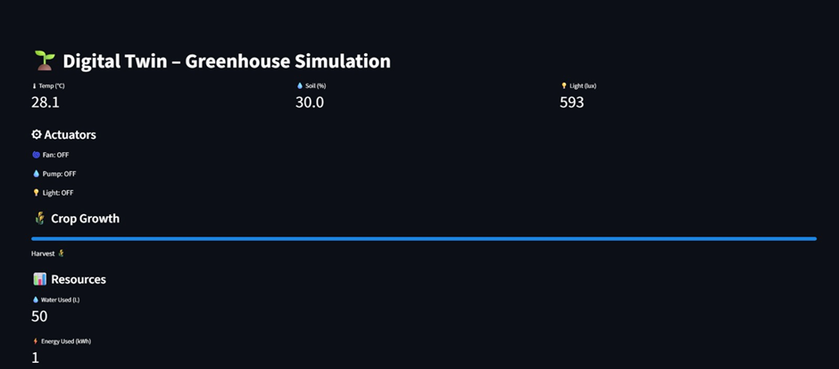
Fig. 1 Real-Time Greenhouse Simulation Dashboard
Fig. 1 shows the greenhouse simulation dashboard operating in real time, continuously displaying the core environmental readings — temperature, humidity, CO₂, and actuator states. The interface gives a grower an immediate read of current conditions at a glance.
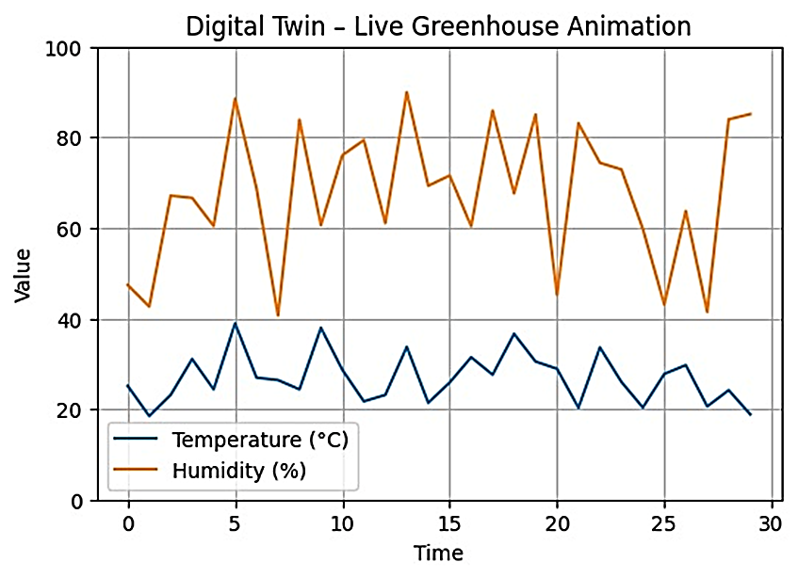
Fig. 2 Live Time-Series Visualization of Greenhouse Temperature and Humidity Dynamics
Fig. 2 captures live temperature and humidity readings plotted over time, making it easy to spot trends and short-term fluctuations. This matters because greenhouse management depends on understanding how conditions are evolving, not just where they stand at a single moment. That said, the visualization stays descriptive. It doesn't surface the derived decision metrics — vapor pressure deficit, dew point, or cumulative high-humidity exposure — that growers actually need when assessing disease risk. A humidity curve that climbs but gives no indication of how long it has stayed elevated doesn't help with disease management.
Alongside the visualization layer, the system includes a CNN-based disease classifier and a crop recommendation module. The disease component takes a leaf image, runs it through standard preprocessing — resize, normalize — and outputs a predicted disease label with a confidence score. The crop recommendation module pulls from soil and environmental data to suggest a suitable crop. Both serve their purpose within the demo interface, but they operate as independent advisory tools rather than components of a connected control loop. There's no feedback between the disease detector and the actuators — a flagged pathogen doesn't trigger any corrective response.
As a starting point, the baseline system does what it was designed to do: visualize greenhouse conditions, display actuator states, and show basic climate trends. That makes it a useful reference for comparison. What it isn't is a digital twin in any complete sense — there's no continuous model aligning simulated behavior with measured data, no simulation layer for testing control strategies safely, and no optimization that accounts for crop stage or disease risk. Those are exactly the gaps AgriTwin-GH addresses.

PROPOSED SYSTEM
The AgriTwin-GH system is built around three principles: data-driven, modular, and simulation-validated. It combines open-source environmental datasets, AI-based analysis, and a digital twin simulation layer to support intelligent greenhouse management without requiring a live sensor network. Each component is designed to work independently, integrate cleanly with the rest, and be extended or replaced without disrupting the system.

Overall Architecture Diagram
AgriTwin-GH is built around a continuous data pipeline. Environmental sensors supply readings on temperature, humidity, soil moisture, and light while cameras capture plant images; both streams enter a unified processing layer that cleans, normalizes, and structures the data before any analysis begins. This preprocessing step isn't a formality — it's what lets the downstream models behave reliably rather than chasing noise. Once the data is ready, it flows to models that extract patterns and generate predictions. The growth stage classifier and disease detector work from images; the forecasting models work from time-series environmental readings. Together they give the system two complementary views of greenhouse health: what the environment is doing and what the crop looks like.
Predictions are where the system's value shows up most clearly. Rather than just summarizing the current moment, AgriTwin-GH projects how growth stages will progress, how diseases might develop, and how the environment is likely to shift. Those forecasts feed into the decision layer, which converts model outputs into concrete actuator adjustments — how much to water, ventilate, heat, or illuminate. The digital twin ties everything together. It runs as a virtual greenhouse where different control strategies can be tested before anything is pushed into the real environment. The loop is closed — predictions feed back into the models — forming a system that continuously learns and adapts. A web interface and 3D visualization surface everything in real time so growers can monitor status and step in when needed.
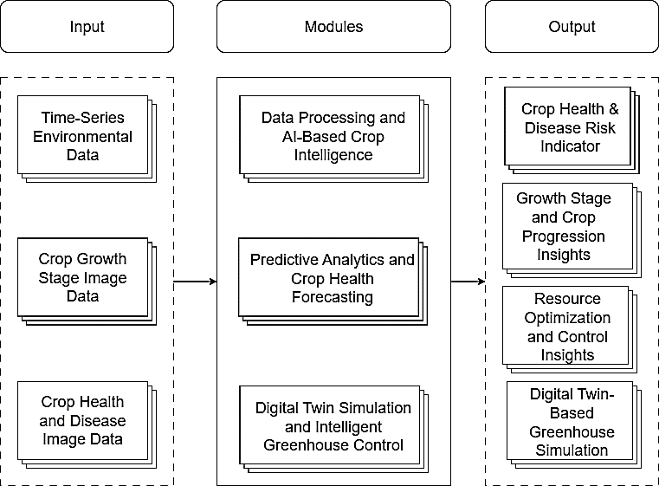
Fig. 3 High-Level Architecture Diagram of AgriTwin-GH
Fig. 3 illustrates the high-level architecture of the proposed AgriTwin-GH framework, depicting the flow of data from input acquisition to intelligent decision outputs. The architecture is structured into three primary layers: input data sources, core processing modules, and system outputs.

Data Processing and AI-Based Crop Intelligence
The Data Processing and AI-Based Crop Intelligence module is where raw greenhouse data gets turned into something the system can learn from and act on. It handles everything from environmental time-series feeds and external weather inputs to plant images — processing all of them through a shared pipeline before passing the results to downstream classification and detection models. Emphasis is on quality first: data is validated and cleaned before anything else happens, representations are standardized across sources, and features are engineered to carry genuine agronomic meaning. Only then do the deep learning models for growth stage classification and disease detection take over. The output is a dependable stream of environmental and visual crop information that the forecasting and control layers can rely on.
The pipeline starts with raw weather API data, which typically arrives messy — incomplete, timestamp-inconsistent, and occasionally corrupted. The first step integrates all available sources, then passes the combined dataset through a cleaning stage that flags and removes bad entries and fills gaps using appropriate imputation strategies. Once clean, the data is aligned along a common time axis so that temperature, humidity, CO₂, and light readings can be analyzed together rather than independently. Feature engineering runs on top of that aligned dataset, pulling out environmental indicators that better reflect what is actually happening in the greenhouse. The output is a structured, reliable dataset that the AI models can work with confidently.
Translating outdoor weather readings into meaningful indoor greenhouse estimates requires a deliberate series of engineering steps. Raw inputs — temperature, humidity, wind speed, solar radiation, timestamps — are standardized and expanded into hourly records to simulate continuous monitoring. From these, the module derives indoor climate variables: temperature, humidity, and air velocity. It also computes agronomic indicators specific to crop management: dew point, Vapor Pressure Deficit (VPD) as a measure of plant transpiration demand, and a leaf wetness proxy that flags prolonged high humidity likely to favor disease development. The resulting dataset — covering indoor temperature, humidity, air velocity, CO₂, solar radiation, VPD, dew point, and leaf wetness — becomes the input for all AI modules in the system.
Daytime Condition:
$$ΔT=0.02×SolarRadiation (1) \\ IndoorTemp=OutdoorTemp+ΔT (2)$$
Nighttime Condition:
$$IndoorTemp=OutdoorTemp+1.5 (3)$$
Indoor humidity is estimated from the combined influence of temperature variation and evapotranspiration.
Daytime Condition:
$$IndoorHumidity=OutdoorHumidity-\left(0.5×ΔT\right)+0.4 (4)$$
Nighttime Condition:
$$IndoorHumidity=OutdoorHumidity+5 (5)$$
Indoor air velocity is derived from outdoor wind speed using a scaling factor that accounts for structural attenuation.
$$IndoorAirVelocity = OutdoorWindSpeed×0.1 (6)$$
CO₂ concentration in the greenhouse differs between day and night, driven by plant photosynthesis and respiration.
Daytime:
$$IndoorCO2​=400-\left(0.05×SolarRadiation\right) (7)$$
Nighttime:
$$IndoorCO2​=440 (8)$$
Dew point temperature is approximated using the Magnus formula applied to indoor temperature and humidity.
$$DewPoint=IndoorTemp-5\left(100-IndoorHumidity\right) (9)​$$
VPD quantifies the drying demand of greenhouse air — a key driver of transpiration and disease risk.
Saturation Vapor Pressure:
$$SVP = 0.6108 * e^{\left\{\frac{17.27T}{T + 237.3}\right\}} (10)$$
Actual Vapor Pressure:
$$AVP = SVP * \left(\frac{RH}{100}\right) (11)$$
Vapor Pressure Deficit:

$$VPD=SVP-AVP (12)$$
Here, T is indoor temperature in degrees Celsius (°C) and RH is indoor relative humidity expressed as a percentage (%).
Leaf wetness is flagged when relative humidity remains above a sustained threshold.
$$LeafWetness=1 if IndoorHumidity>85\% for ≥ 3 consecutive hours (13)$$
Otherwise:
$$LeafWetness=0 (14)$$
The growth stage classification module identifies where a tomato plant is in its development from a single image — removing the need for someone to check manually. Input images are resized, normalized, and augmented before being classified into one of six stages: Seedling, Early Vegetative, Flowering Initiation, Flowering, Unripe Fruit, and Ripe Fruit. Each stage is visually distinguishable through cues like leaf size and structure, presence or absence of flowers, and fruit development. The classification backbone is EfficientNetB3, chosen for its ability to detect fine structural and color detail. On top of it sits a custom head: global average pooling, dense layers with ReLU, batch normalization, and dropout, with softmax providing confidence-weighted predictions rather than a hard label. Training proceeds in two phases — the classification head is trained first to establish basic feature patterns, then selected upper backbone layers are fine-tuned for better accuracy. Controlled augmentation is applied throughout, and class-weighted loss functions ensure the model doesn't under-perform on rarer growth stages.
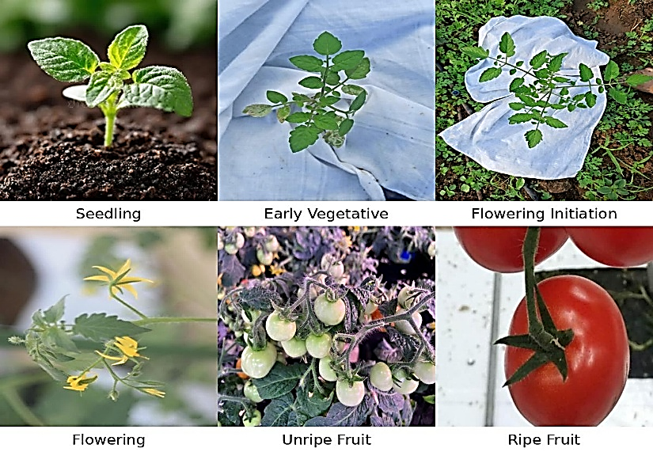
Fig. 4 Tomato Crop Growth Stages Dataset Samples
Fig. 4 illustrates sample input images representing different crop growth stages used for training and evaluating the growth stage classification model.
The disease detection module scans tomato leaf images for six conditions: Early Blight, Late Blight, Leaf Mold, Powdery Mildew, Spider Mite infestation, and Healthy. By recognizing visible symptoms — spots, discoloration, textural irregularities — the model can flag potential disease early, before it spreads across the crop. The backbone is EfficientNetB0, which handles fine-grained, localized image patterns efficiently. Like the growth module, it uses a pre-trained backbone with a custom head and softmax outputs, giving both a class prediction and a confidence score. Training follows the same two-stage transfer learning approach, and because disease symptoms appear across a wide range of lighting conditions, orientations, and severity levels, this module applies heavier augmentation: rotations, flips, zoom, brightness variation. Weighted loss handles class imbalance, with categorical cross-entropy as the optimization objective. The result is a robust, confidence-aware detection system well-suited for real-world greenhouse deployment.
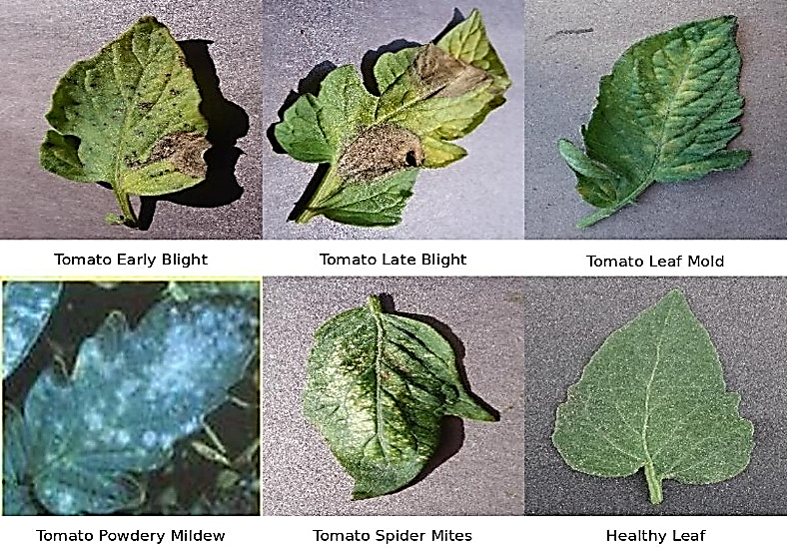
Fig. 5 Tomato Leaf Disease Classification Dataset Samples
Fig. 5 illustrates sample input images of plant leaves showing various disease conditions used for training and evaluating the disease detection model.
The crop intelligence workflow takes plant images, preprocesses them, extracts features through EfficientNet, and runs two parallel classifiers — one for growth stage and one for disease. The outputs are stage labels and disease predictions that feed directly into the greenhouse monitoring and control pipeline.
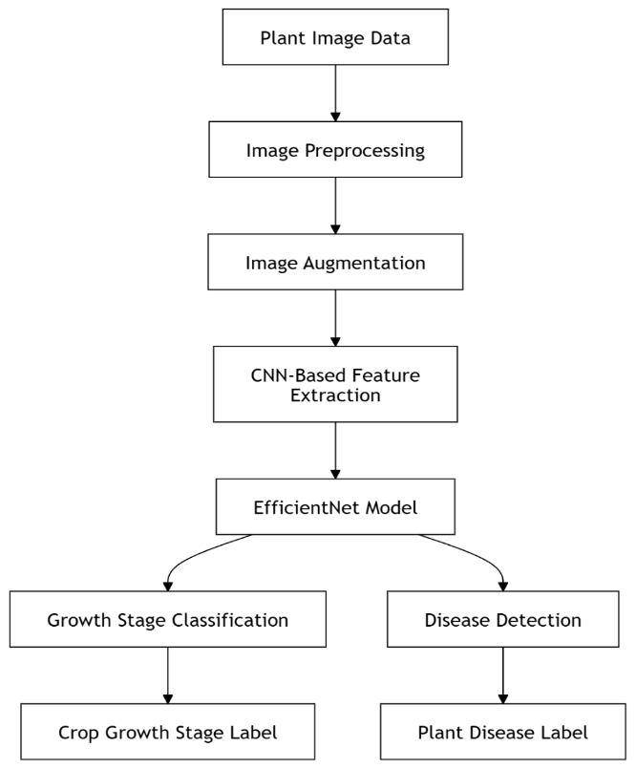
Fig. 6 Growth Stage Classification and Disease Detection Workflow
Fig. 6 illustrates the Growth Stage Classification and Disease Detection workflow, showing how plant image data is processed to generate crop growth stage predictions and plant disease detection results.

Predictive Analytics and Crop Health Forecasting
The Predictive Analytics and Crop Health Forecasting module is built around three connected models: a weather forecaster, a growth progression model, and a disease progression model. The weather model looks ahead at how indoor temperature, humidity, and light will shift over the coming hours. The growth model builds on that by estimating how the plant itself will develop — which stage is next, and when the transition happens. The disease model rounds it out by projecting how active pathogen conditions are likely to evolve given recent environmental history. Together, these three perspectives — environment, growth, and disease — give the system a forward view that no individual sensor can provide on its own. Instead of waiting for something to go wrong, the module lets the system see it coming.
The greenhouse weather forecasting module predicts external weather conditions — air temperature, relative humidity, wind speed, and solar radiation — over 24- and 48-hour windows. These forecasts are critical because actuator decisions should account for where the environment is heading, not just where it stands right now. The module takes a hybrid approach, deliberately mixing three complementary methods: a Chronos-T5-small transformer that captures long-range temporal patterns, XGBoost that models structured feature relationships, and stacked LSTM networks that learn sequential trends. All three are trained on time-ordered historical data using a strict chronological split between training, validation, and test sets — an important design choice that prevents future values from leaking into the training phase. Before training, the data goes through careful preprocessing: missing values are imputed, variables are aligned along a common timeline, and an extensive set of engineered features is created — cyclical time encodings, seasonal indicators, lag features, rolling statistics, and interaction terms like temperature-humidity relationships and solar-wind effects. These features help each model capture both stable background patterns and sudden environmental shifts. The Chronos model is fine-tuned in two stages, starting with a warm-up phase, and its outputs partly inform the XGBoost and LSTM models. XGBoost is trained separately per variable and per horizon to contain error accumulation. The LSTM uses sliding window inputs, dropout, gradient clipping, and adaptive learning rate scheduling for stability. Final predictions are produced by blending all three models' outputs using weights optimized per variable and per horizon. A Random Forest classifier then maps numerical outputs to sky-condition categories for cleaner dashboard presentation.

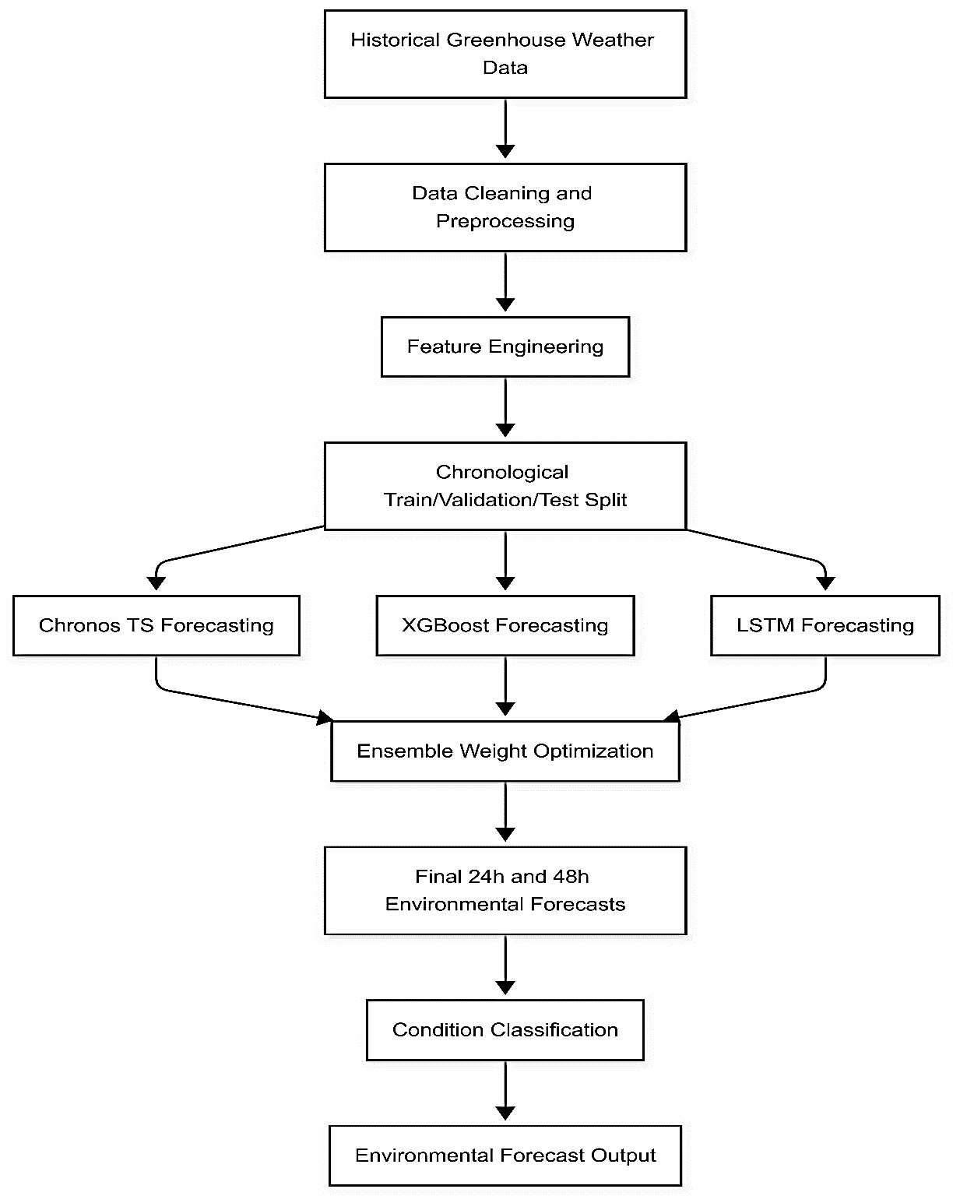
Fig. 7 Weather Forecasting Model Architecture

Fig. 7 illustrates the high-level workflow of the weather forecasting model, including data preprocessing, feature engineering, multiple model training, ensemble fusion, and generation of future environmental forecasts.
Disease progression modeling represents a meaningful step forward from simply detecting whether a pathogen is present in a crop environment. The model tells a continuous and evolving story, tracking how a disease develops from its earliest signs, intensifies under favorable conditions, or retreats in response to treatment and environmental change. At every step in the sequence, it simultaneously estimates what is happening right now, anticipates what severity might look like at defined points in the future, and characterizes the direction of change with genuine specificity. This multi-layered output gives the system something a basic detection tool fundamentally cannot provide — the ability to raise a flag before conditions become critical, giving growers the opportunity to respond while options are still plentiful and damage is still preventable, rather than scrambling to contain a situation that has already moved beyond easy control. The training data that powers this system is constructed with considerable care and deliberate specificity. Records are stored in a wide format, where each disease of interest receives its own dedicated set of features and prediction targets — presence indicators that signal whether a given condition has taken hold, current severity scores that quantify how advanced the disease is at a given moment, projected severity values at multiple future horizons, and trend classifications derived from rule-based logic that reflects domain knowledge about how diseases behave over time. This structure is important because it preserves the nuance specific to each disease while still allowing the model to operate across multiple conditions within a single unified framework — avoiding the considerable overhead of maintaining entirely separate systems for every pathogen of concern. The trend labels themselves are generated through a principled comparison of current severity measurements against future values, with both evaluated against biologically meaningful thresholds. Before any learning takes place, the raw data undergoes thorough and systematic preparation. Categorical variables are numerically encoded into forms the model can process, gaps in the historical record are addressed through principled imputation strategies tailored to the nature of each feature, and the distributions of input variables are normalized so that no single measurement dominates the learning process simply by virtue of its scale. The temporal structure of the data is also carefully verified — confirming that records follow one another in proper sequence and that no discontinuities exist that might cause the model to learn false patterns from data that was never truly connected. Once the data is clean and validated, the dataset is divided chronologically rather than randomly. Training proceeds strictly on historical data, and evaluation is conducted on what comes after, ensuring there is no pathway for future information to enter the model's learning phase and inflate its apparent performance in ways that would not hold in real deployment. Gradient boosting models are introduced first, trained on this prepared dataset and used to establish a well-grounded and interpretable baseline. These models draw on lag-based features — representations of recent conditions that give the model a sense of how the immediate past relates to what follows — and they handle presence classification and severity regression as separate but complementary prediction tasks. Gradient boosting is particularly well-suited to uncovering non-linear relationships between environmental inputs and disease dynamics, capturing the kind of threshold effects and interaction patterns that simpler linear approaches would miss entirely. To keep outputs grounded in reality, predicted severity values are constrained to ranges that reflect what is biologically plausible, preventing the model from generating forecasts that, while mathematically possible, could not occur in practice. On top of this baseline foundation, deep learning components are introduced in the form of Long Short-Term Memory and Gated Recurrent Unit networks — two recurrent architectures that are specifically designed to process sequential data and retain relevant context across extended windows of past observations. These networks do not treat each timestamp as an isolated event but instead carry forward information about what has come before, allowing them to recognize temporal patterns that only become meaningful when viewed across time. A shared encoder sits at the heart of this layer, responsible for learning the general rhythms and dynamics of disease progression that cut across specific conditions and environmental contexts. From this shared representation, task-specific output heads branch off to handle classification and regression independently, each developing specialized competence for its particular objective without redundantly re-learning the temporal context that the encoder has already captured. The training process itself is carefully managed through a combination of techniques: early stopping halts training before the model begins memorizing noise in the training data, adaptive learning rate schedules allow optimization to progress efficiently without stalling or oscillating, dropout regularization encourages the model to develop robust and generalizable representations rather than brittle ones, and model checkpointing ensures that the best-performing configuration encountered during training is preserved even if performance fluctuates in later epochs. The final prediction the system delivers is not a choice between the gradient boosting and deep learning approaches, but a deliberate and optimized combination of both. Outputs from each component are blended using weights determined by their relative performance on the validation set, producing a hybrid forecast that is more stable and more resilient to noisy or incomplete inputs than either approach would be on its own. This ensemble strategy reduces overall prediction variance and gives the system a more dependable footing when real-world data arrives in the messy, irregular form.

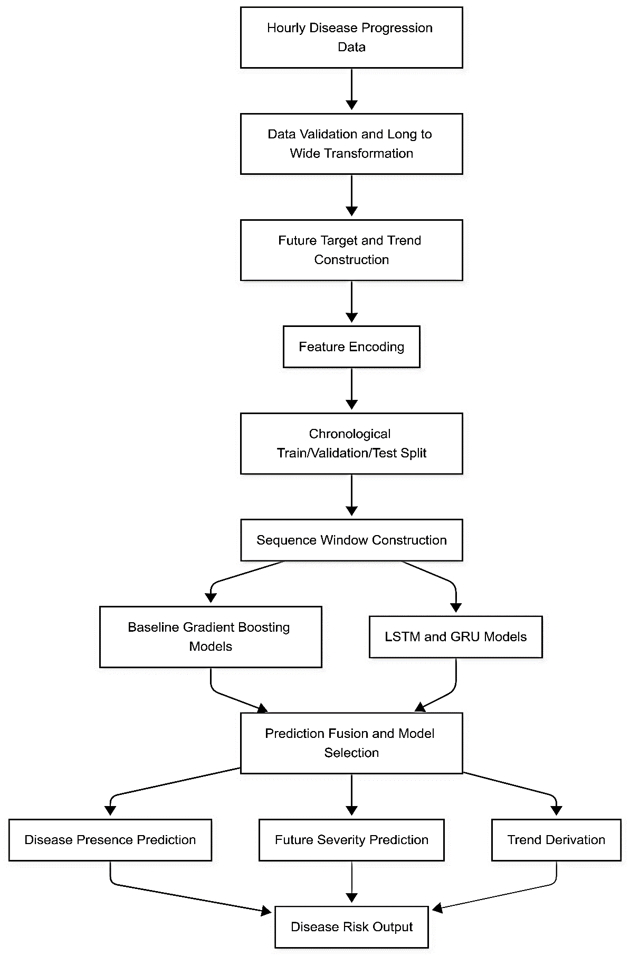
Fig. 8 Disease Progression Prediction Model Architecture

Fig. 8 illustrates the high-level workflow of the disease progression model, including data transformation, feature encoding, sequence modeling, and prediction of disease presence, severity, and future trends.
The growth progression model approaches crop development not as a static classification problem but as a continuously unfolding temporal process — one that demands forward-looking intelligence rather than simple moment-to-moment labeling. At every hourly time step, the model produces several simultaneous outputs: an assessment of the plant's current growth stage, a prediction of the next stage expected to follow, an estimate of how many hours remain before that transition occurs, and probabilistic forecasts of whether a stage change will happen within the next 24 and 48 hours. This combination of outputs is what gives the system its practical depth. Rather than merely confirming where a plant stands at any given moment, it tells the grower where things are heading and how soon — enabling resources, inputs, and interventions to be positioned ahead of time rather than scrambled together in response. Nutrient profiles can be adjusted before a plant enters flowering. Harvest logistics can be organized before the ripe stage is reached. The model's value lies not just in what it knows, but in how early it knows it. The data the system learns from consists of hourly sensor records spanning multiple complete and independent growth cycles. Each cycle captures the continuous progression of a plant from its earliest stage through to maturity, logging air temperature, relative humidity, light intensity, and CO₂ concentration at every step along the way. The decision to train across multiple distinct cycles — rather than deriving all lessons from a single plant's trajectory — is a deliberate one. Each cycle represents a different instance of growth unfolding under somewhat different environmental conditions, and exposing the model to this variety teaches it to recognize growth dynamics in a general sense, not just in the narrow context of one particular run. Before any of this data enters the training pipeline, every cycle undergoes thorough validation. Temporal continuity is confirmed so that no gaps disrupt the sequence, stage ordering is checked against expected biological progressions, transitions that would be physiologically impossible are identified and removed, and missing sensor readings are addressed through interpolation and smoothing techniques that preserve the signal without introducing artificial artifacts. One of the more technically compelling aspects of this system is how its prediction targets are constructed. For each individual timestamp in the dataset, the model's targets are derived not from the present moment alone but from carefully controlled look-aheads within the same growth cycle. This process generates, for every observation, a next-stage label, an estimate of the hours remaining until the next transition, transition probabilities at the 24- and 48-hour horizons, and a normalized progression index that captures how far through its current stage the plant has advanced. This index is a subtle but meaningful addition — it distinguishes a plant that has just entered a stage from one that is deep within it, even when the stage label itself remains the same. Taken together, these derived targets transform what would otherwise be a flat record of sensor readings into a richly structured temporal forecasting dataset, where every data point carries information not just about the present but about the trajectory ahead. Feature engineering further enriches the input representation before it reaches the model. Lag features capture the recent history of each environmental variable, rolling averages smooth out transient spikes and reveal sustained trends, and variability indicators quantify how stable or erratic conditions have been over recent windows. Together, these additions help the model detect momentum — the sense that conditions have been building in a particular direction — as well as short-term fluctuations that can meaningfully influence the pace of development. The dataset is partitioned at the cycle level rather than the observation level, meaning that entire growth cycles are assigned to training, validation, or testing sets. This design choice is critical: it prevents any form of temporal leakage between evaluation phases and ensures that performance estimates reflect how well the model generalizes to growth cycles it has never encountered before. Before the deep learning architecture is introduced, tree-based models — specifically Random Forest and Gradient Boosting — are trained on flattened representations of the input features and benchmarked as reference points. These models handle complex feature interactions naturally and offer interpretable, well-calibrated outputs, making them genuinely useful baselines rather than token comparisons. Their limitation, however, is fundamental to their structure: they process each observation as an independent snapshot and have no mechanism for learning how patterns evolve across time. This is precisely the gap that the recurrent architecture is designed to fill. At the center of the deep learning system sits a multi-output LSTM network built around a shared temporal encoder and a set of task-specific output heads. The shared encoder processes sequential windows of sensor observations and distills from them a learned representation of time-dependent growth dynamics — the rhythms, transitions, and environmental responses that tend to characterize plant development across stages. This shared representation is then passed to separate specialized heads, each responsible for a different prediction target: one for stage classification, another for transition likelihood estimation, and a third for the regression of time-to-transition. This branching architecture allows each head to develop specialized competence without duplicating the work of learning temporal context, which remains the shared encoder's responsibility. Training is governed by early stopping to prevent the model from memorizing noise, adaptive learning rate schedules that allow optimization to proceed smoothly without stalling, and dropout layers that improve robustness by discouraging over-reliance on any particular feature or pathway. Because the different prediction tasks vary in difficulty and scale, the total training loss is a weighted combination of task-specific loss functions — a design that prevents easier tasks from dominating the learning signal at the expense of harder ones. Once predictions leave the model, a final layer of post-processing rules ensures that outputs remain biologically grounded. Predicted stage sequences are validated against known transition logic so that the model can never suggest a progression that contradicts how plants actually develop. In deployment, inference runs continuously on rolling windows of the most recent sensor observations, updating predictions with each new data point as it arrives. This gives the system a live, self-refreshing view of where each plant stands and where it is going — a quiet but consequential capability that turns a forecasting model into a genuine operational presence within the growing environment.

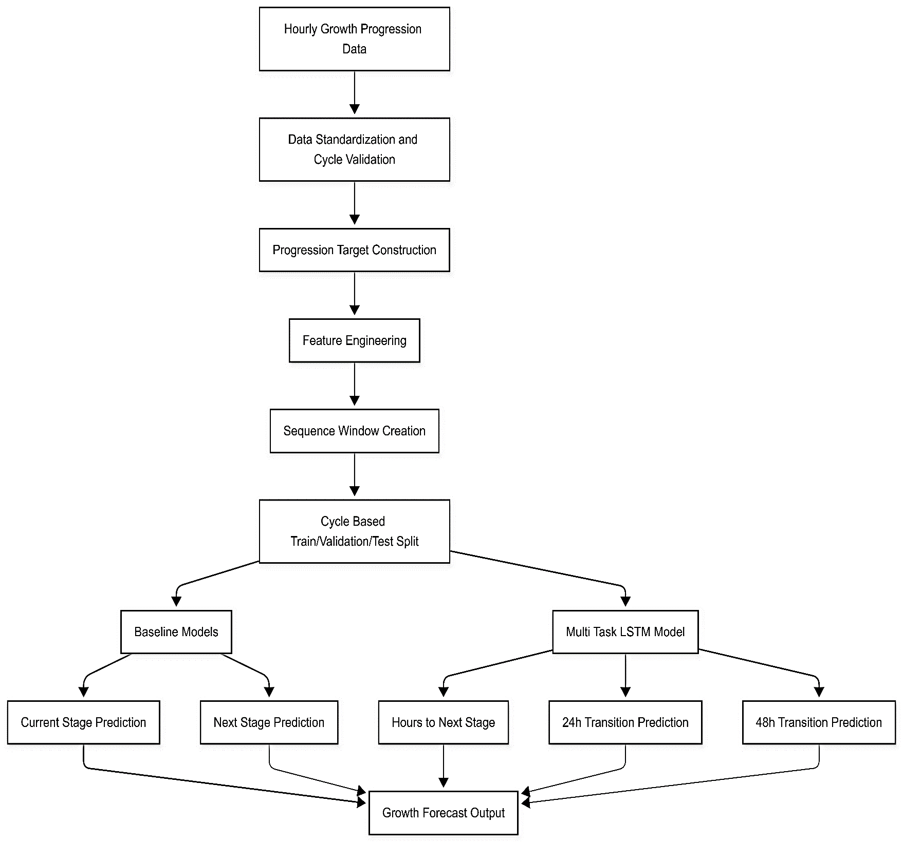
Fig. 9 Growth Progression Prediction Model Architecture

Fig. 9 illustrates the high-level workflow of the growth progression model, showing data validation, feature engineering, sequence modeling, and multi-task prediction of plant growth stages and transitions.

Digital Twin Simulation and Intelligent Greenhouse Control
This module is where all the system's intelligence converges into a unified control loop. It brings together environmental forecasts, crop growth and disease progression data, and real-time greenhouse state information to form a live picture of how the greenhouse is behaving — then acts on it. Rather than responding only to what has already happened, the system continuously projects forward, letting control decisions anticipate problems rather than chase them. The backbone of this is a digital twin closed-loop simulation — a virtual greenhouse that evolves step by step, feeding its own outputs back as inputs for the next cycle. Running alongside it, a Model Predictive Control (MPC) framework calculates actuator settings — temperature, ventilation, irrigation, lighting — based on both what the system knows now and what it expects to happen over the planning horizon. A FastAPI backend and a web-based frontend surface the simulation state in real time, and a 3D greenhouse visualization gives users an intuitive view of what is happening inside the virtual environment. Monthly historical summaries are generated automatically to support longer-term performance review.
The Model Predictive Control layer is the decision-making engine. At each time step, it takes the current greenhouse state — temperature, humidity, CO₂, soil moisture, light, VPD, leaf wetness — alongside disease risk, growth stage, and a 24-hour weather forecast, and computes a sequence of actuator actions that minimizes deviations from the crop's ideal conditions over a defined planning horizon. What makes this different from a simple rule-based controller is that the MPC reasons ahead: it considers how actions taken now will affect conditions later and respects operational constraints from the outset rather than treating them as violations to be corrected after the fact. State dynamics are modeled using an ARX (AutoRegressive with eXogenous inputs) framework, which predicts how each greenhouse variable responds to actuator commands and external weather disturbances. The general state transition equation is:
$$x_{i}\left[k+1\right]= α_{i}x_{i}\left[k\right]+ Σ β_{ij}u_{j}\left[k\right]+ Σ γ_{im}d_{m}\left[k\right]+ ε_{i} (15)$$
Where, represents the i-th state variable at time step k, represents the j-th control input, represents external disturbances (e.g., outdoor weather), αi is the state persistence coefficient, ​ represents actuator influence, represents disturbance influence, and captures modeling uncertainty. Indoor temperature dynamics are especially important and are modeled explicitly:$x_{i}\left[k\right]u_{j}\left[k\right]d_{m}\left[k\right]β_{ij}γ_{im}ε_{i}$
$$T\left[k+1\right]= α_{T}T\left[k\right]+ γ_{ext}\left(T_{ext}\left[k\right]- T\left[k\right]\right)+ γ_{sol}S\left[k\right]+ β_{heat}u_{heater}+ β_{fan}u_{fan}+ β_{vent}u_{vent } (16)$$
Where, T[k] is indoor temperature, Text[k] is outdoor temperature, S[k] is solar radiation, and the actuator terms represent heating and cooling contributions. Comparable ARX formulations govern humidity, CO₂, and light. Soil moisture follows a water balance equation, and VPD is derived analytically:
$$VPD = \left(1 -\frac{RH}{100}\right)× SVP\left(T\right) (17)$$
Where, RH is relative humidity and SVP(T) is saturation vapor pressure at temperature T. The MPC solves a finite-horizon cost minimization problem:
$$\min{J\left(u\right)}= Σ_{\left\{k=0\right\}}^{\left\{N-1\right\}}l\left(x_{k}, u_{k}, u_{\left\{k-1\right\}}\right)+ V_{f\left(x_{N}\right) } (18)$$
Where, N is the prediction horizon, ℓ(⋅) is the stage-wise running cost, and is the terminal cost. This formulation optimizes both immediate performance and longer-term system behavior simultaneously. The main running cost component is setpoint tracking:$V_{f\left(x_{N}\right)}$
$$l_{track}= Σ m_{i}w_{i}{\left(\frac{x_{k}^{i}- x*^{i}}{σ_{i}}\right)}^{2} (19)$$
Where, is the predicted state, is the stage-specific environmental setpoint, ​ is a normalization factor, wi is a variable-specific weight, and mi is a modifier that reflects current environmental context. This keeps penalization balanced across variables with different physical units. Additional cost terms account for energy consumption:$x_{k}^{i}x*^{i}σ_{i}$
$$l_{energy}= Σ c_{j}u_{j}^{2} (20)$$
water usage:
$$l_{water}= c_{w}u_{irrigation}^{2} (21)$$
and actuator smoothness:
$$l_{smooth}= Σ λ_{j}{\left(u_{j\left[k\right]}- u_{j\left[k-1\right]}\right)}^{2} (22)$$
Together these terms penalize wasteful resource use and abrupt actuator changes. Disease risk is integrated directly into the objective through a sigmoid-based function:
$$R_{disease}=\frac{1}{1 + e^{\left\{-\left(a_{1}RH + a_{2}LW + a_{3}T + a_{4}VPD + b\right)\right\}}} (23)$$
where RH is humidity, LW is leaf wetness, T is temperature, VPD is vapour pressure deficit, and a_{i}, b are learned parameters. This risk penalty pushes the optimizer toward environmental conditions that keep pathogen pressure low — a proactive disease management strategy built directly into the control law. The MPC operates in a receding horizon fashion: at each step it generates a full control sequence but applies only the first action, then re-solves with updated information at the next cycle. A fallback rule-based controller activates automatically if the optimization fails or becomes infeasible, maintaining safe operation through priority logic on temperature bounds, humidity thresholds, soil moisture, and disease risk flags.
The Digital Twin simulation loop is the execution engine that keeps the virtual greenhouse alive step by step. At each cycle, it takes the current greenhouse state, applies the MPC's actuator commands and the prevailing weather, advances the physical model by one time step, and feeds the result back as the starting point for the next cycle — a true closed loop. The schedule is multi-rate: the simulation advances every 5 minutes, MPC re-optimizes every 15 minutes, and image-based observations refresh every 30 minutes. This balances computational cost against control responsiveness without breaking the continuous loop. The state-chaining equation that defines the closed loop is:$x_{k}u_{k}w_{k}$
$$x_{\left\{k+1\right\}}= f\left(x_{k}, u_{k}, w_{k}\right) (24)$$
Where, is the greenhouse transition function implemented by the ARX physics model. Each step's output is the next step's input — there is no external data injection after the first step. Greenhouse conditions emerge naturally from the interplay of control actions, weather disturbances, and plant-environment dynamics. Inside each 5-minute step, the Digital Twin Engine runs eight sequential phases: updating greenhouse climate through the transition model; recomputing disease risk from the post-step environmental state; performing effect attribution that decomposes each state change into contributions from weather, actuators, and baseline dynamics; checking disease-environment flags for conditions like sustained high humidity or wet leaves; computing energy and water consumed in the step; calculating per-variable state deltas; detecting whether any state value hit a physical bound and required clamping; and evaluating setpoint error against the stage-specific target profile. The result is a physically predicted next state enriched with explainable diagnostics. The ARX state update equation is:$f\left(⋅\right)x_{\left\{k+1\right\}}$
$$x_{i}\left[k+1\right]= α_{i}x_{i}\left[k\right]+ Σ β_{ij}u_{j}\left[k\right]+ Σ γ_{im}d_{m}\left[k\right]+ ε_{i} (25)$$
Where, is the i-th state variable at step k, is the j-th actuator input, is the m-th external disturbance, is the self-decay or persistence coefficient, is the actuator influence coefficient, is the disturbance gain, and is process noise. The DT engine delegates all physical state propagation to the GreenhouseTransitionModel — the same model used by the MPC planner — ensuring the virtual greenhouse and the optimizer's internal dynamics remain consistent. Among individual state equations, temperature is especially important because it directly drives crop stress, humidity coupling, and disease risk. The temperature update is:$x_{i}\left[k\right]u_{j}\left[k\right]d_{m}\left[k\right]α_{i}β_{ij}γ_{im}ϵ_{i}$
$$T\left[k+1\right]= α_{T}T\left[k\right]+ γ_{ext}\left(T_{ext}\left[k\right]- T\left[k\right]\right)+ γ_{sol}S\left[k\right]+ β_{heat}u_{heater}+ β_{fan}u_{fan}+ β_{vent}u_{vent} (26)$$
Where, T[k] is current indoor temperature, Text[k] is outdoor temperature, S[k] is solar radiation, is heater output, is fan speed, and is vent opening. The thermal persistence term captures heat retention, ​ models heat exchange with the outside, captures solar gain, and the β terms represent actuator effects: heater raises temperature, fan and vent reduce it. Humidity follows a similar ARX form:$u_{heater}u{}_{fan}u_{vent}α_{T}γ_{ext}γ_{sol}$
$$H\left[k+1\right]= α_{H}H\left[k\right]+ γ_{ext}\left(H_{ext}\left[k\right]- H\left[k\right]\right)+ β_{fog}u_{fogger}+ β_{fan}u_{fan}+ β_{vent}u_{vent}+ ET (27)$$
Where, H[k] is indoor humidity, Hext[k] is outdoor humidity, ​ is fogger duty cycle, and ET is evapotranspiration baseline. The persistence term captures humidity inertia, external moisture exchange is modeled explicitly, and actuator terms account for both humidification and drying effects. Humidity is particularly consequential in tomato greenhouses because sustained elevated humidity is the primary driver of fungal disease risk. Soil moisture follows a water-balance form:$u_{fogger}α_{H}γ_{ext}β$
$$SM\left[k+1\right]= α_{sm}SM\left[k\right]+ β_{irr}u_{irr}-λ_{ET}\max\left(T\left[k+1\right]- 15, 0\right) (28)$$
Where, SM[k] is soil moisture at step k, ​ is irrigation quantity, is moisture persistence, ​ is irrigation gain, and ​ is an evapotranspiration loss term that scales with indoor temperature above a baseline — warmer conditions accelerate soil drying. The CO₂ model captures both active injection and ventilation losses:$u_{irr}α_{sm}β_{irr}λ_{ET}max\left(T\left[k+1\right]- 15, 0\right)$
$$C\left[k+1\right]= α_{C}C\left[k\right]+ β_{inj}u_{CO2}+ β_{plant}ϕ_{light\left[k\right]}+ β_{vent}u_{vent}+ γ_{vent}u_{vent}\left(C_{amb}- C\left[k\right]\right) (29)$$
Where, C[k] is CO₂ concentration, is CO₂ valve opening, is vent opening, ​ is ambient outdoor CO₂, and is a light-dependent crop uptake factor. Light itself is modeled as memoryless:$u_{CO2}u_{vent}C_{amb}ϕ_{light}$
$$L\left[k+1\right]= γ_{sol}S\left[k\right]+ β_{LED}u_{LED} (30)$$
Where, L[k+1] is light intensity, S[k] is solar radiation, and is LED intensity. Light at each step depends only on current solar and LED contributions — there is no carry-over from previous steps. After the physical state update, the engine re-derives agronomic indicators from the new state. VPD is recomputed from post-step temperature and humidity using the Tetens equation:$u_{LED}$
$$VPD = e_{s}\left(T\right)\left(1 -\frac{RH}{100}\right) (31)$$
Where, is saturation vapour pressure at temperature T and RH is relative humidity. VPD summarizes the drying demand of air and strongly influences transpiration, leaf wetness duration, and disease favourability. Alongside VPD, a leaf wetness proxy is recomputed from humidity and dew-point proximity. Disease risk is then recalculated fresh from the new post-step environmental state — not carried forward from the previous step — using the sigmoid-based multi-factor formulation:$e_{s}\left(T\right)$
$$R_{disease}= w_{1}σ\left(H; c_{H}, s_{H}\right)+ w_{2}σ\left(LW; c_{LW}, s_{LW}\right)+ w_{3}σ\left(T; c_{T}, s_{T}\right)+ w_{4}\left(1 - σ\left(VPD; c_{V}, s_{V}\right)\right) (32)$$
Where, ​ is the recomputed disease-risk score, H is indoor humidity, LW is leaf wetness, T is indoor temperature, VPD is vapour pressure deficit, ​ are weighting coefficients, and σ(⋅) is a sigmoid function parameterized by center c and slope s. This formulation allows the DT to flag disease-favorable conditions even when no fresh image-based disease observation has been received. Effect attribution — identifying what drove each state variable's change — is computed as additive components. For temperature the decomposition is:$R_{disease}w_{i}$
$$ΔT = \left(p_{decay}^{T}- 1\right)T + p_{ext}^{T}\left(T_{ext}- T\right)+ p_{solar}^{T}solar + p_{heat}^{T}u_{heat}+ p_{fan}^{T}u_{fan}+ p_{vent}^{T}u_{vent} (33)$$
Where, ΔT is the stepwise temperature change and the p coefficients capture contributions from persistence decay, outdoor heat exchange, solar gain, heater output, fan cooling, and vent cooling. Equivalent decompositions are computed for humidity, soil moisture, CO₂, and light. These values are stored in the step diagnostics so the system can explain, for example, whether a temperature rise was mainly driven by solar loading or heater operation. Resource accounting runs at the same per-step resolution. Step energy consumption is:
$$E_{step}= sum\left(P_{j}u_{j}Δt\right) (34)$$
Where, ​ is step energy in kWh, ​ is the rated power of actuator j, is the normalized actuator level (0–1), and Δt is step duration in hours. Step water use is:$E_{step}P_{j}u_{j}$
$$W_{step}= q_{irr}Δt (35)$$
Where, ​ is step water consumption and is the irrigation flow term. These values accumulate across the loop and are recorded in diagnostics and historical snapshots, making the simulation useful not only for environmental prediction but also for post-run cost and efficiency analysis. To keep simulations biologically realistic over long runs, the loop includes automatic growth-stage progression: when a stage's configured duration elapses, the loop advances to the next stage and resets the stage-hour counter automatically — allowing a full crop cycle from seedling to ripe to unfold without manual intervention. Emergency-triggered MPC re-solves add a reactive safety layer on top of the scheduled 15-minute cadence: if any step produces a state that crosses an emergency threshold, the optimizer is invoked immediately rather than waiting for the next scheduled interval.$W_{step}q_{irr}$
The frontend, API, and monthly snapshot system form what users actually interact with. They work together to make the digital twin's outputs readable, actionable, and stored for retrospective analysis. The frontend presents environmental monitoring, crop growth intelligence, disease risk summaries, historical trends, and manual control options — covering day-to-day greenhouse monitoring without requiring technical expertise. FastAPI handles communication between system layers: delivering simulation updates to the UI, validating incoming user inputs, and bridging the 3D visualization over a live API connection. The monthly snapshot layer compresses high-frequency simulation telemetry into PostgreSQL summaries, capturing energy and water usage, environmental exposure patterns, actuator behavior, disease incidents, and stage-by-stage growth progression. These summaries make month-over-month comparison practical and give operators a longer-term view of system performance.
The Unity-based 3D greenhouse model gives the digital twin a physical face. Vents, fans, irrigation systems, lighting rigs, and crop plants are all modeled as interactive objects that respond dynamically to actuator commands flowing from the live simulation. The model runs in WebGL and is accessible directly from a browser with no additional installation required. Crop plants change appearance as growth stage predictions advance, and the scene shifts with dynamic lighting and time-of-day effects. Real-time synchronization happens through the API — simulation state updates continuously drive changes in the virtual scene. Color shifts and animations communicate system status through immediate visual cues rather than data tables, making complex simulation states readable at a glance for growers who don't need to parse raw diagnostic logs.

RESULT ANALYSIS

Results of Crop Growth Stage Classification Model
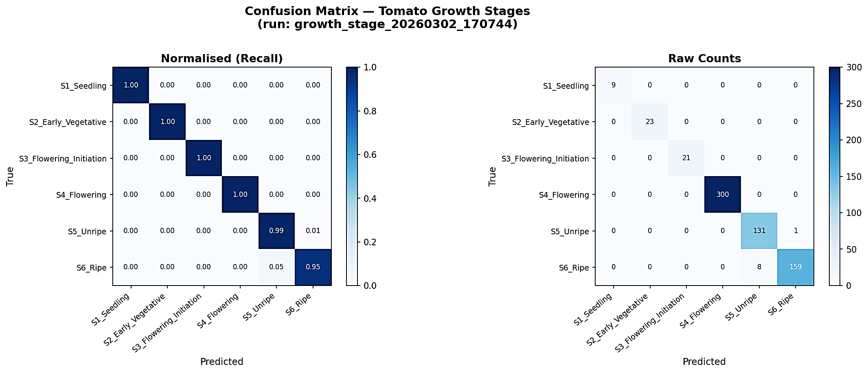
Fig. 10 Confusion Matrix of Tomato Growth Stage Classification Model
Fig. 10 shows the confusion matrix for the growth stage classification model. Classification performance is strong across most stages, with the model correctly distinguishing the visually distinct seedling and ripe phases. Minor confusion occurs between adjacent mid-growth stages, which is expected given how gradually leaf morphology transitions.
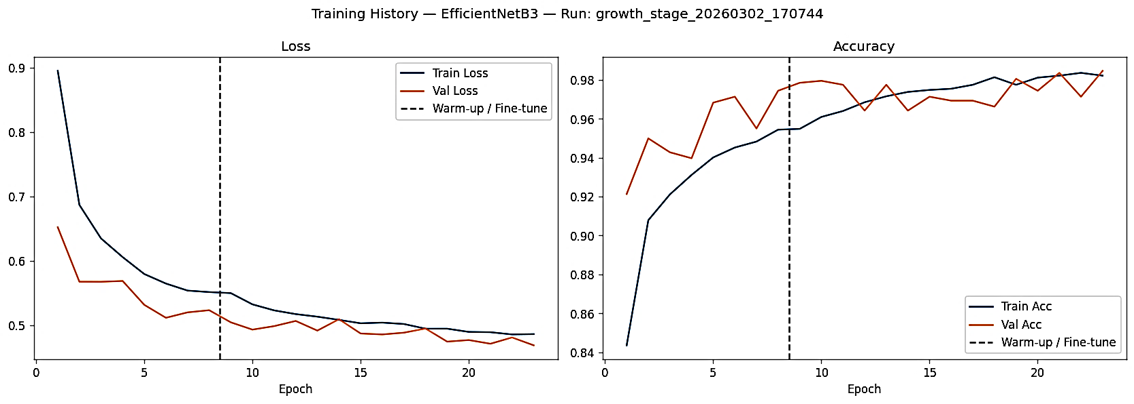
Fig. 11 Training Accuracy of the Growth Stage Classification Model
Fig. 11 shows the training and validation accuracy curves over epochs. Both curves converge steadily and track each other closely, indicating that the model learned generalizable features without overfitting to the training distribution.

Fig. 12 Training Loss of the Growth Stage Classification Model
Fig. 12 shows the training and validation loss curves. Both decrease consistently across epochs and converge to a stable value, confirming that the model training was stable and well-regularized.

Results of Plant Disease Detection Model
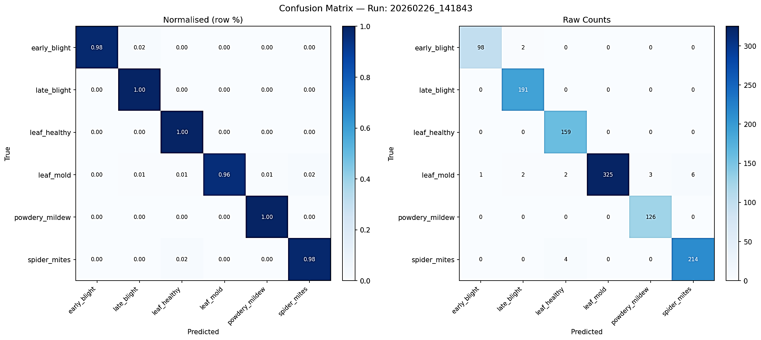
Fig. 13 Confusion Matrix of Tomato Disease Detection Model
Fig. 13 shows the confusion matrix for the plant disease detection model across six disease categories. The model correctly identifies the majority of disease classes, with healthy leaves and late blight achieving particularly clear separation.
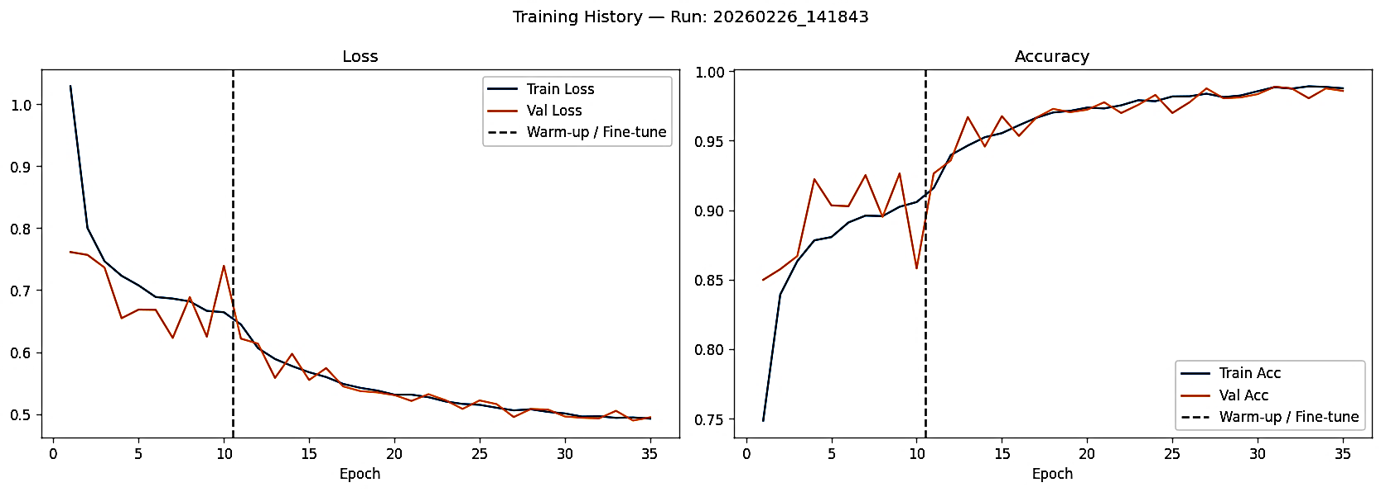
Fig. 14 Training Accuracy of the Disease Detection Model
Fig. 14 shows the training and validation accuracy curves for the disease detection model. The two curves track closely from early epochs, suggesting the augmentation and regularization strategies were effective.

Fig. 15 Training Loss of the Disease Detection Model
Fig. 15 shows the training and validation loss curves for the disease detection model. Both curves decrease smoothly and stabilize, indicating consistent learning without instability or divergence.

Results of Weather Forecasting Model
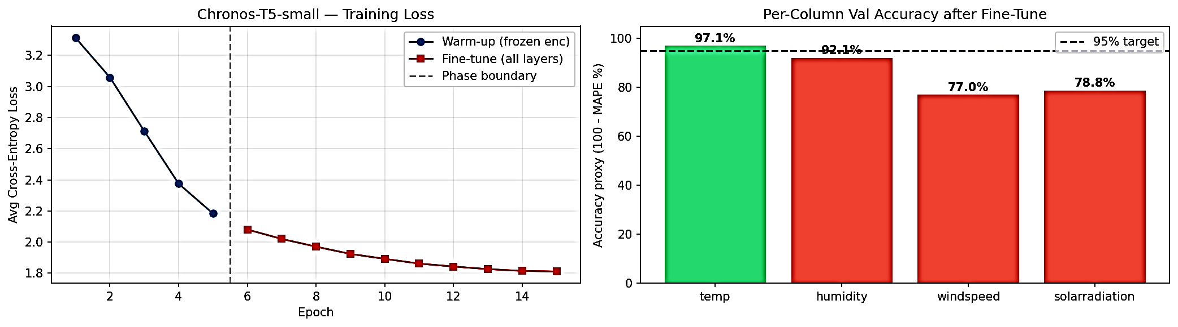
Fig. 16 Chronos Model Training Curve
Fig. 16 shows the training loss curve for the Chronos model after fine-tuning. The loss decreases steadily across training steps, indicating that the model successfully adapted its pre-trained representations to greenhouse-specific forecasting tasks.

Fig. 17 Chronos Model Validation Accuracy after Fine-Tuning
Fig. 17 shows validation accuracy for the Chronos model after fine-tuning, confirming that the model's learned patterns generalize to held-out data.

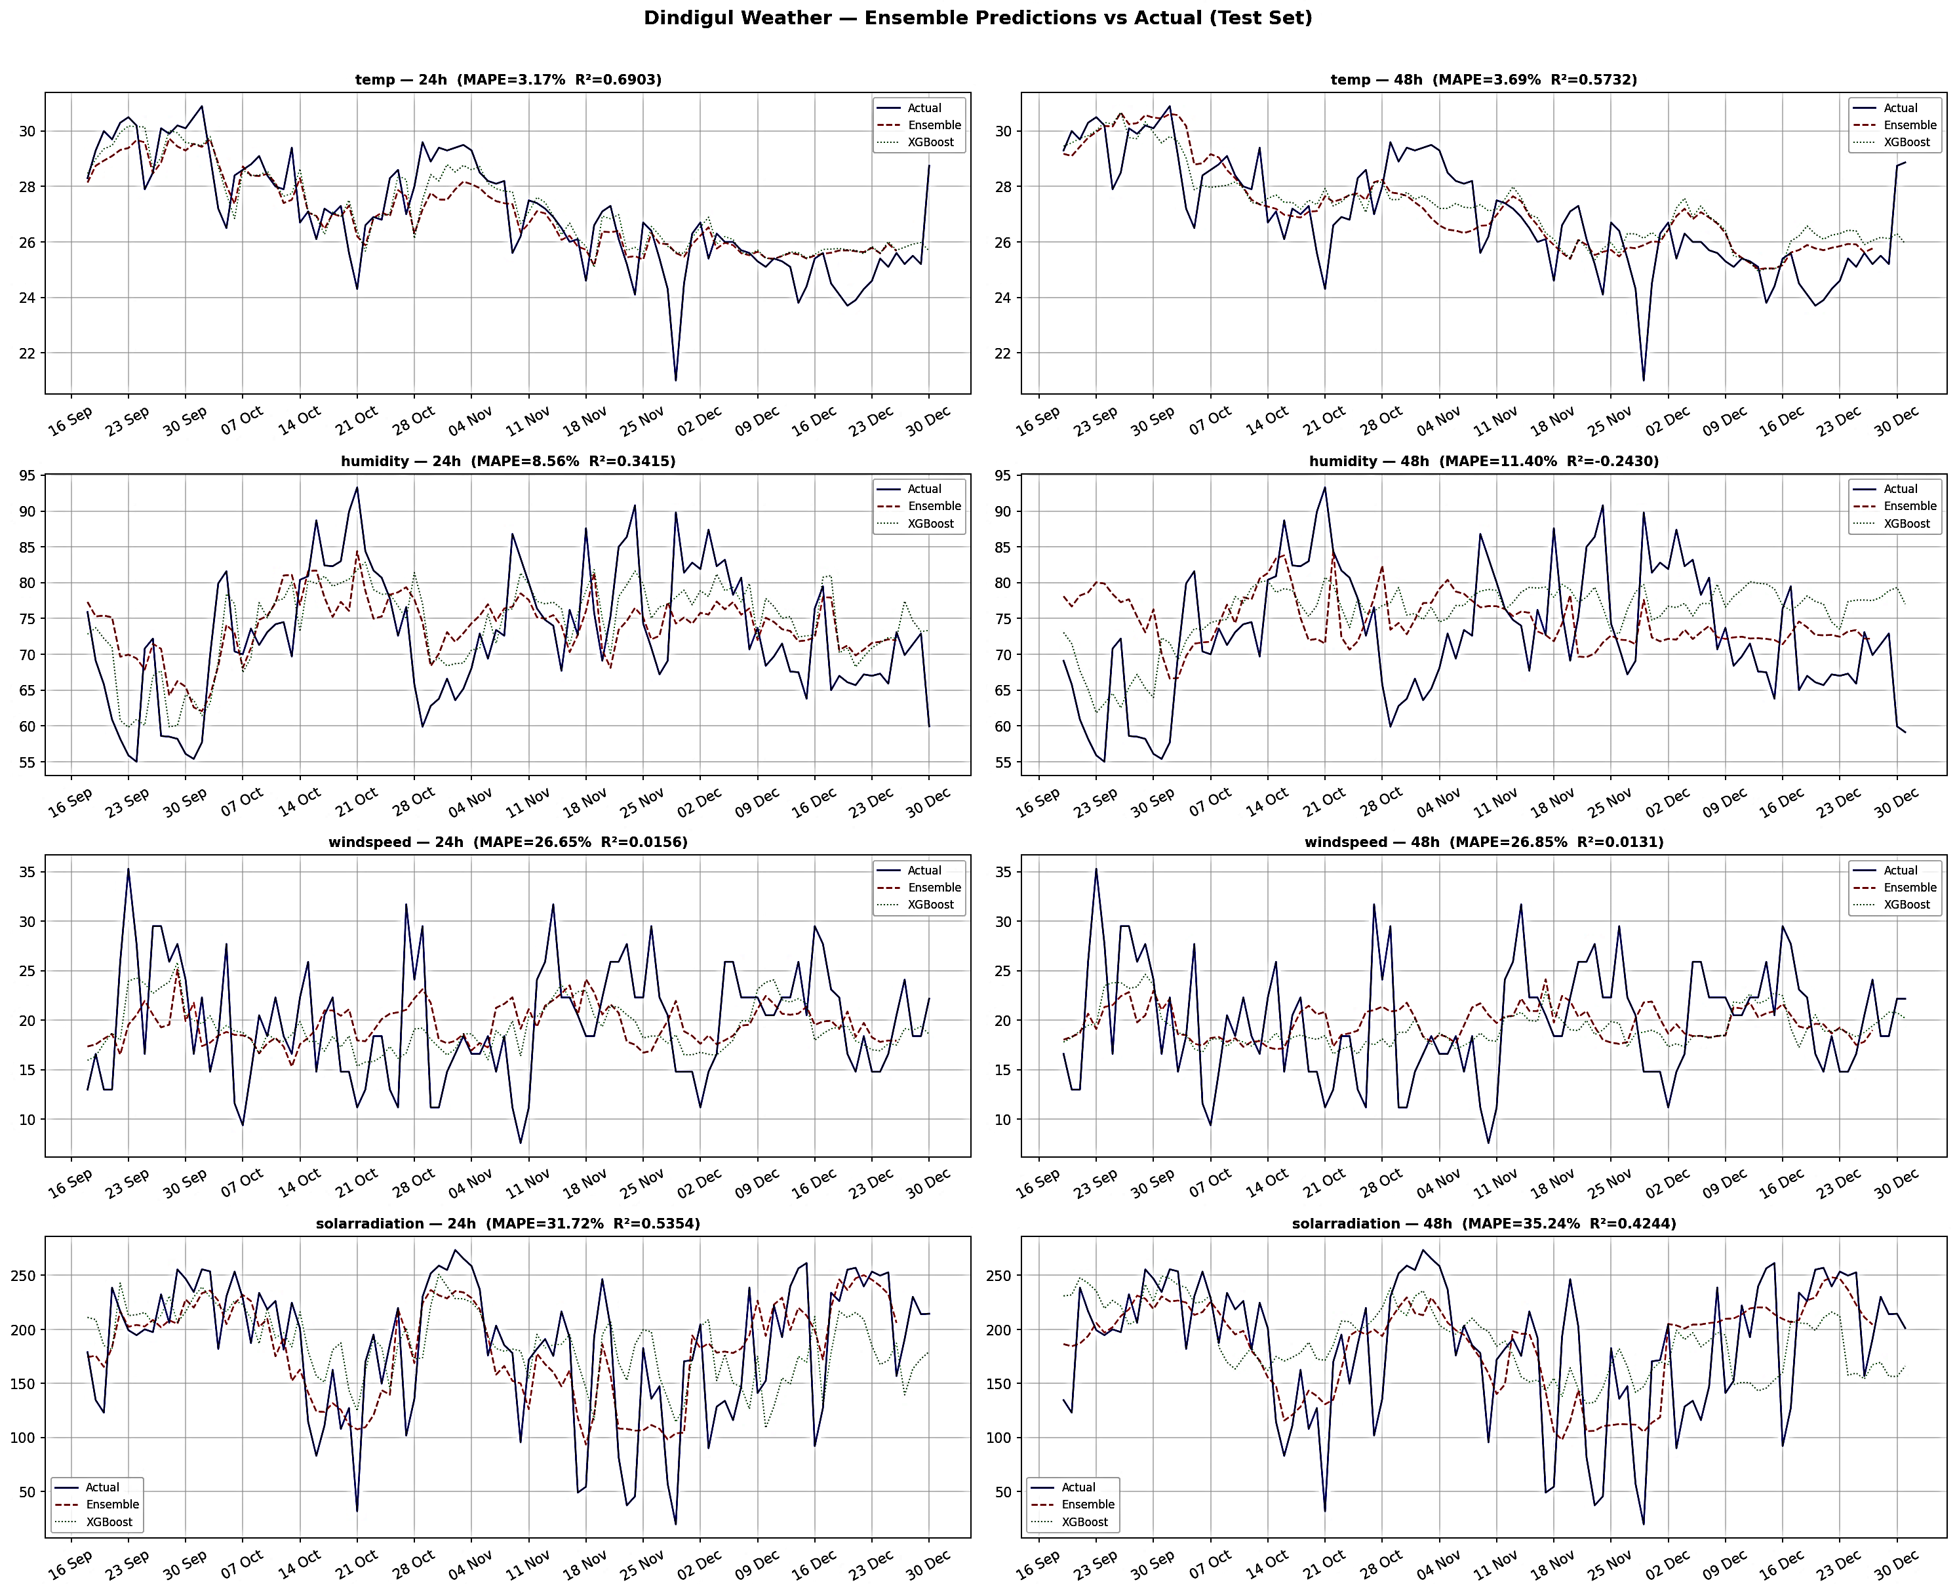
Fig. 18 Ensemble Weather Forecast Prediction versus Actual Values

Fig. 18 compares ensemble weather forecast predictions against actual recorded values. The predicted curves closely track the measured data across both temperature and humidity, with prediction residuals remaining small across the illustrated forecast horizon.

Results of Disease Progression Model
Table I summarizes disease presence classification performance across standard evaluation metrics. The model achieves high precision, recall, and F1 scores, demonstrating reliable detection of disease presence conditions across the test period.
Table I. Performance Metrics for Disease Presence Classification Model
Metric | Value
Micro F1 Score | 0.800
Macro F1 Score | 0.801
Accuracy | 0.907
Table II presents regression performance for disease severity prediction across all disease outputs in the LSTM model. R² values near 1.0 and low RMSE and MAE figures indicate strong predictive accuracy across forecast horizons.
Table II. Performance Metrics for Disease Severity Prediction
Metric | Value
Mean Absolute Error (MAE) | 3.297
Root Mean Square Error (RMSE) | 7.143
R² Score | 0.618
Table III summarizes disease trend prediction performance. The model correctly classifies whether a disease is emerging, stable, or improving across the majority of test cases, with the highest confusion between closely adjacent trend states.
Table III. Performance Metrics for Disease Trend Prediction
Metric | Value
Macro F1 Score | 0.86
Balanced Accuracy | 0.87
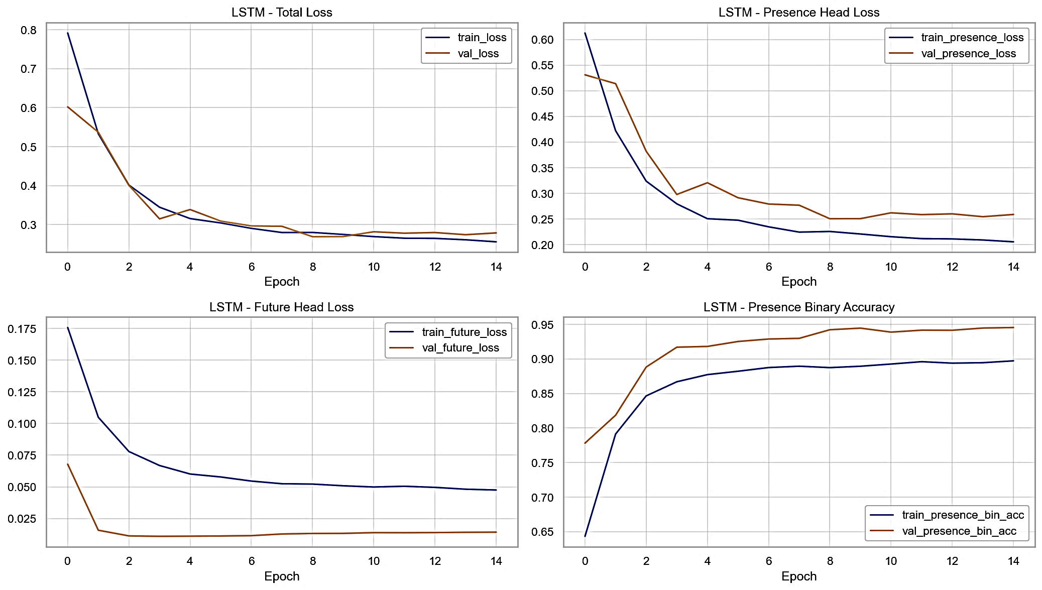
Fig. 19 LSTM Training Loss Curve for Disease Progression Model
Fig. 19 shows the training loss curve for the LSTM-based disease progression model. The loss decreases steadily across epochs and converges, confirming stable learning dynamics and effective sequence modeling.
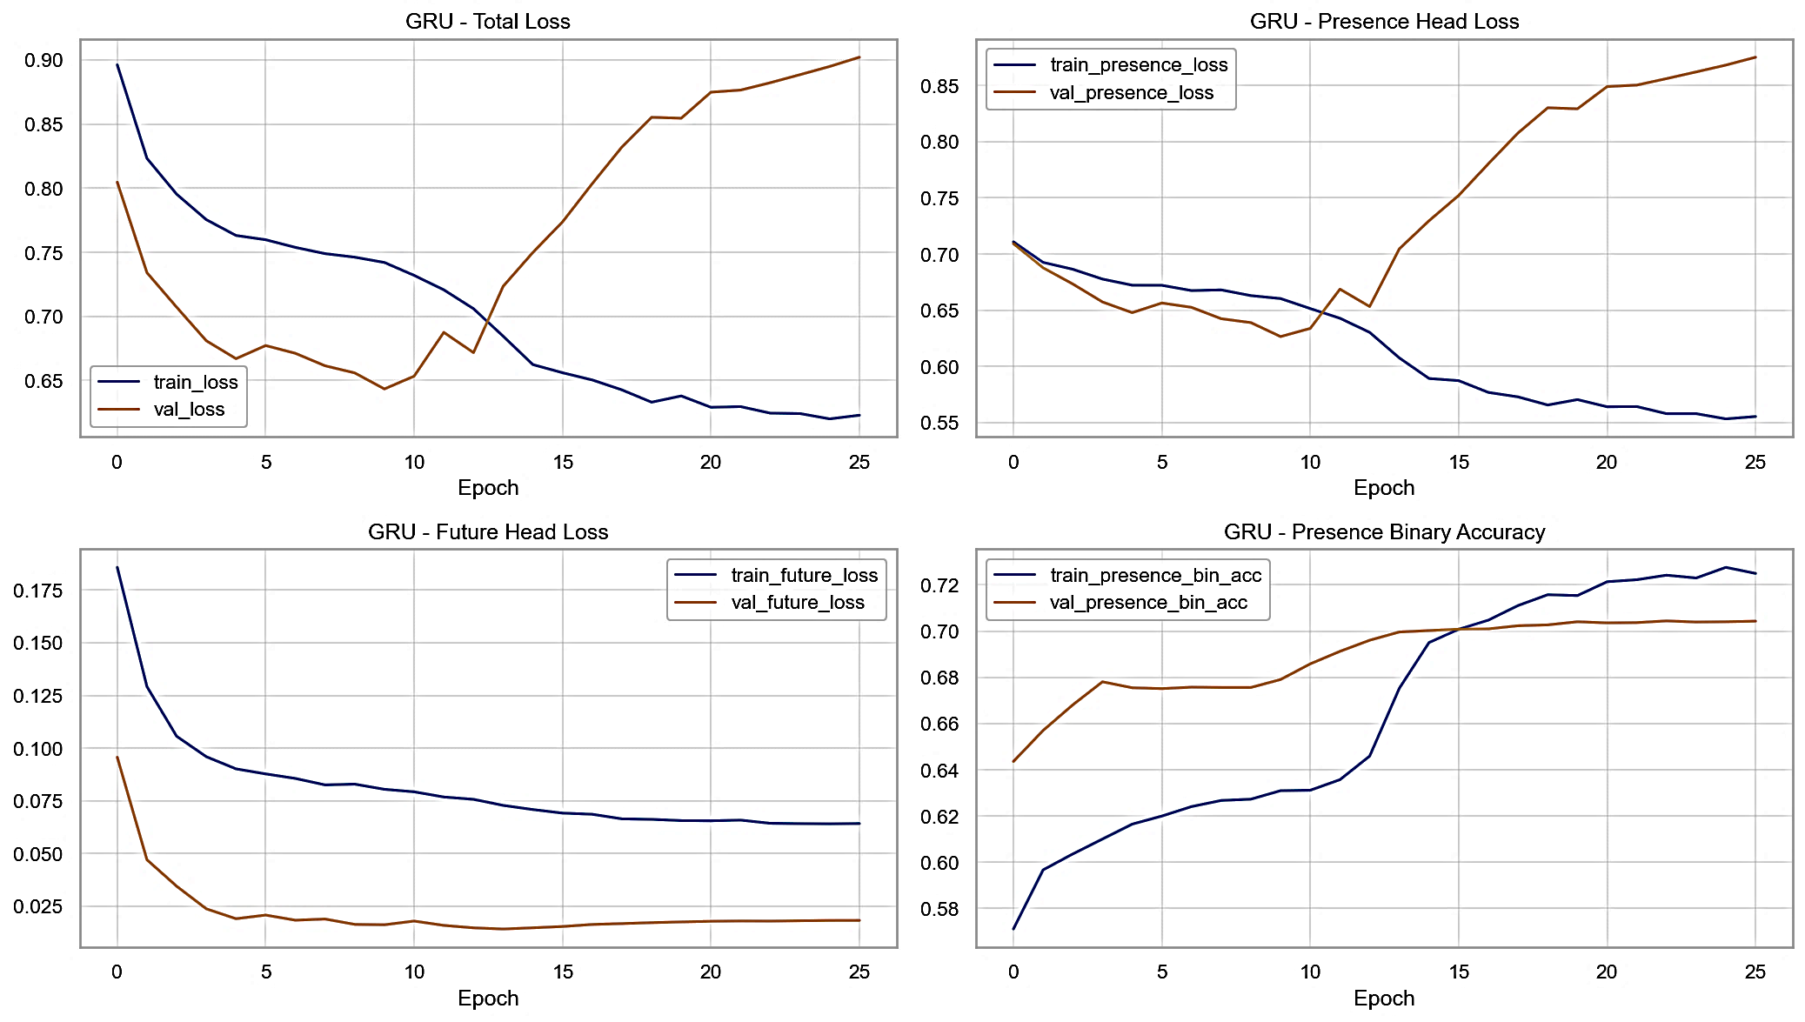
Fig. 20 GRU Training Loss Curve for Disease Progression Model
Fig. 20 shows the training loss curve for the GRU-based disease progression model. The curve follows a similar convergence trajectory to the LSTM, reaching a comparable final loss level.

Results of Crop Growth Progression Model
Table IV presents growth stage classification performance metrics for the progression model. The model distinguishes current growth stages with high accuracy across all six tomato crop stages.
Table IV. Performance Metrics for Growth Stage Classification Model
Metric | Value
Accuracy | 0.97
Precision (Macro) | 0.97
Recall (Macro) | 0.95
F1 Score (Macro) | 0.96
Table V summarizes growth stage transition prediction performance. The model correctly predicts whether a stage transition will occur within the specified horizon in the large majority of test cases.
Table V. Performance Metrics for Growth Stage Transition Prediction
Metric | 24-Hour
Accuracy | 0.97
Precision (Macro) | 0.97
Recall (Macro) | 0.96
F1 Score (Macro) | 0.96
Table VI presents time-to-next-stage prediction performance. The regression metrics confirm that the model provides useful hour-level accuracy in predicting how long a plant will remain in its current growth stage.
Table VI. Performance Metrics for Time-to-Next-Stage Prediction
Metric | Value
Mean Absolute Error (MAE) | 6.58
Root Mean Square Error (RMSE) | 8.45

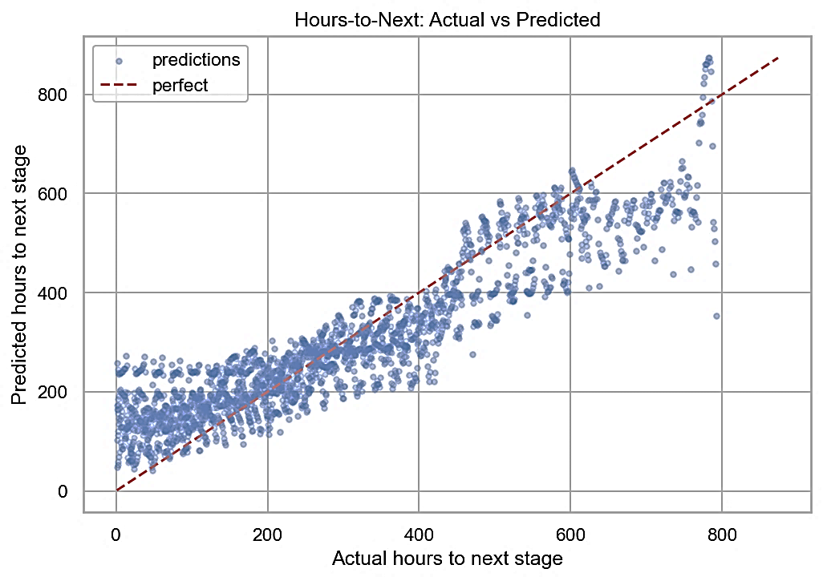
Fig. 21 Actual versus Predicted Hours to Next Growth Stage
Fig. 21 compares actual and predicted hours to the next growth stage transition across the test period. Predicted values track the actual values closely, with residuals that are small and uniformly distributed rather than systematically biased in one direction.
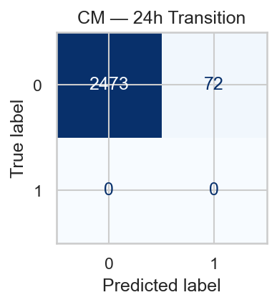
Fig. 22 Confusion Matrix for 24-Hour Growth Stage Transition Prediction
Fig. 22 shows the confusion matrix for 24-hour growth stage transition prediction. The model correctly identifies transitions versus non-transitions in most cases, with false negatives — missed transitions — forming the dominant error type.
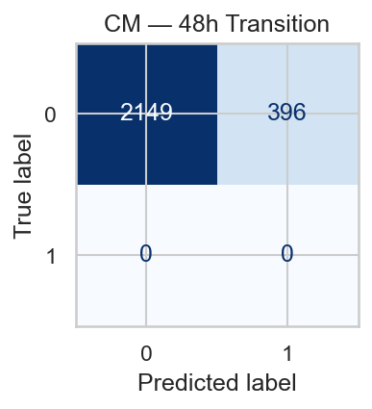
Fig. 23 Confusion Matrix for 48-Hour Growth Stage Transition Prediction
Fig. 23 shows the confusion matrix for 48-hour transition prediction. Performance remains strong over the longer horizon, though with slightly more confusion due to the increased uncertainty at 48 hours.

System Interface and Execution Logs
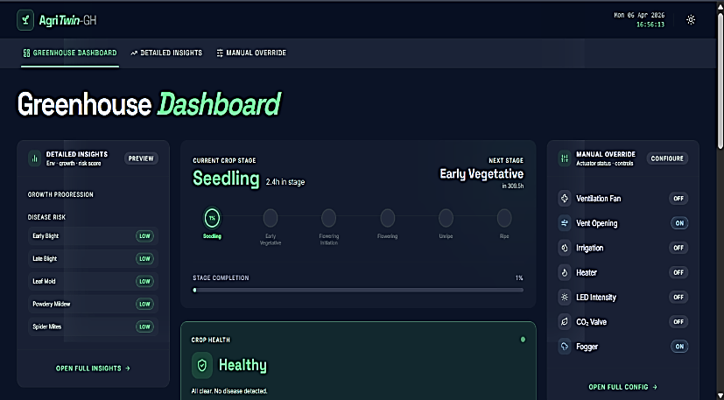
Fig. 24 Greenhouse Dashboard Interface in Dark Mode
Fig. 24 shows the greenhouse dashboard interface in dark mode. The layout displays real-time sensor readings, actuator states, and system-level indicators in a single organized view that lets growers assess overall greenhouse health at a glance.
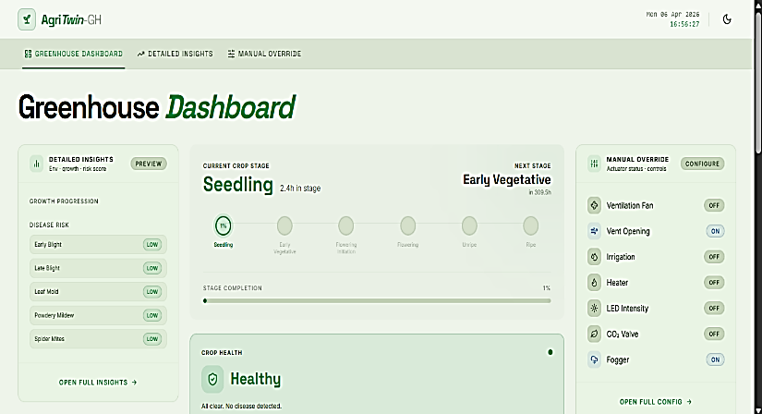
Fig. 25 Greenhouse Dashboard Interface in Light Mode
Fig. 25 shows the same dashboard in light mode, providing an alternative visual theme for different lighting environments without changing any underlying functionality.
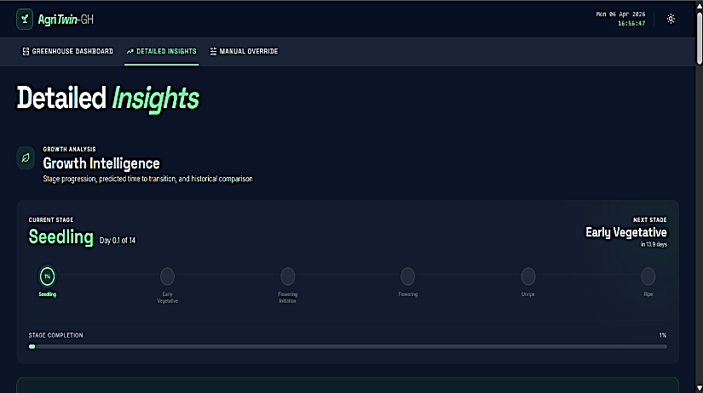
Fig. 26 Growth Intelligence Section in Detailed Insights Interface
Fig. 26 shows the growth intelligence section of the detailed insights interface, which displays predicted current stage, next stage, confidence levels, and estimated time to transition in a compact, readable format.
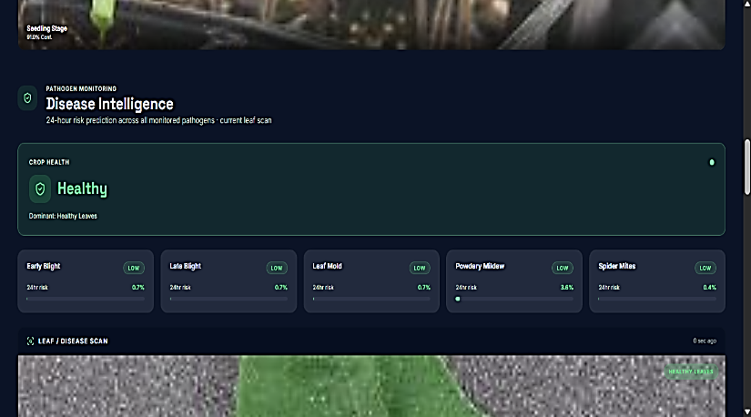
Fig. 27 Disease Intelligence Section in Detailed Insights Interface
Fig. 27 shows the disease intelligence section of the detailed insights interface, presenting per-pathogen risk scores, overall disease risk level, and progression trend indicators drawn from the prediction models.
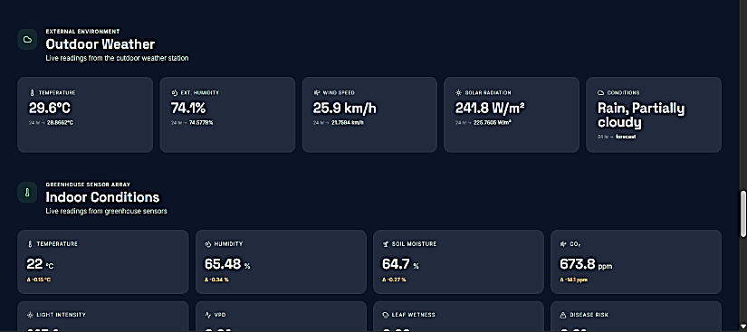
Fig. 28 Environmental Monitoring Section Showing Outdoor and Indoor Conditions
Fig. 28 shows the environmental monitoring section displaying both outdoor weather conditions and estimated indoor greenhouse conditions side by side, making environmental exchanges visible at a glance.
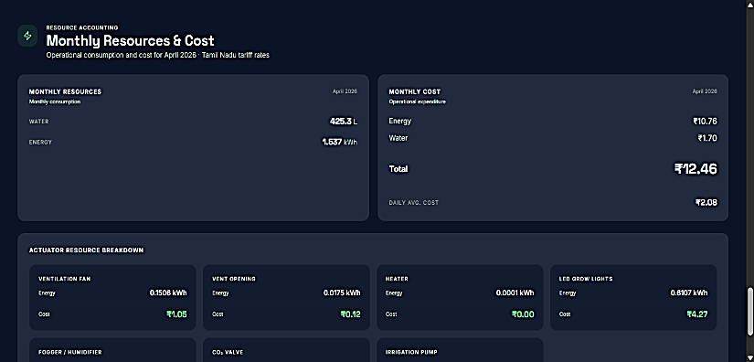
Fig. 29 Monthly Resource Utilization and Cost Analysis Section
Fig. 29 shows the monthly resource utilization and cost analysis section, where energy and water consumption trends are displayed alongside estimated operating costs, supporting ongoing efficiency tracking.
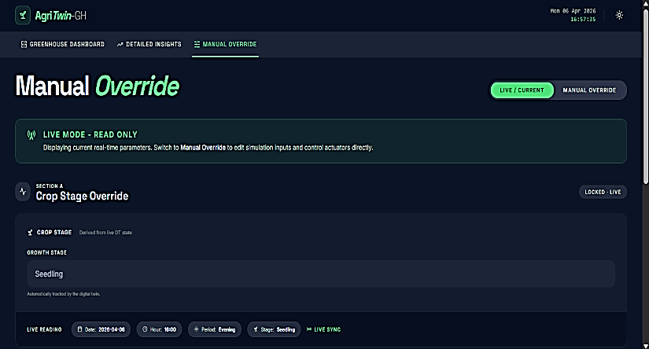
Fig. 30 Manual Override Interface for Growth Stage and Actuator Control
Fig. 30 shows the manual override interface, which allows operators to directly configure growth stage parameters and individually adjust actuator settings when needed outside the automated control loop.
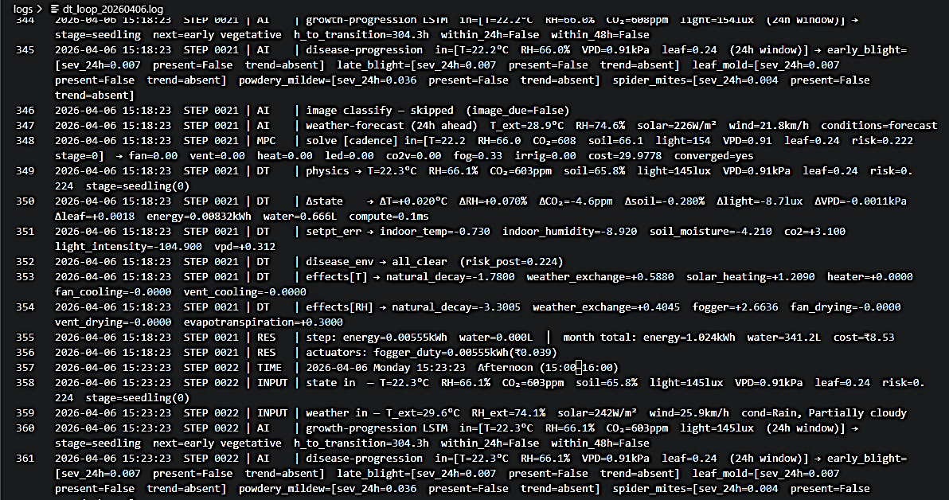
Fig. 31 Digital Twin Closed Loop Execution Log
Fig. 31 shows a sample of the digital twin closed-loop execution log, displaying step-by-step state updates, MPC decisions, AI model outputs, and resource accounting entries as the simulation progresses.

3D Greenhouse Visualization

Fig. 32 Front View of 3D Greenhouse Environment
Fig. 32 shows the front view of the 3D greenhouse environment, displaying the overall structural layout and the exterior appearance of the virtual greenhouse.
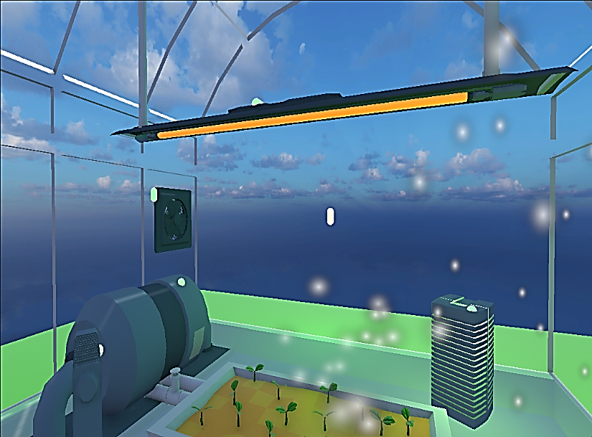
Fig. 33 Internal Right-Side View of Greenhouse in Active State
Fig. 33 shows the interior right-side view of the greenhouse in active state, with actuators visually responding to control commands — fans spinning, vents opened, irrigation systems active.
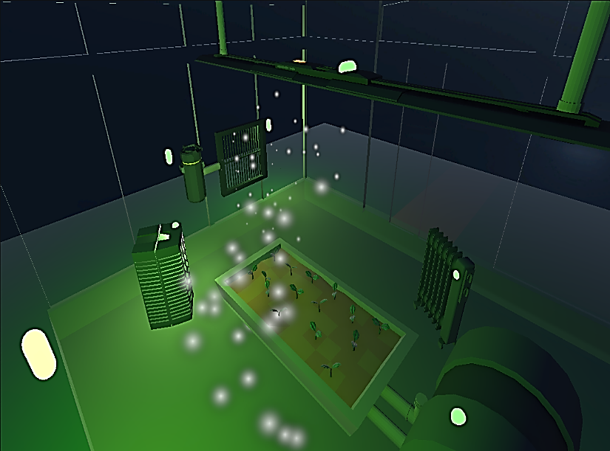
Fig. 34 Top-Left Perspective View of Greenhouse in Active State
Fig. 34 shows a top-left perspective view of the greenhouse interior in active state, providing a broader spatial overview of how actuators and crops are distributed across the structure.
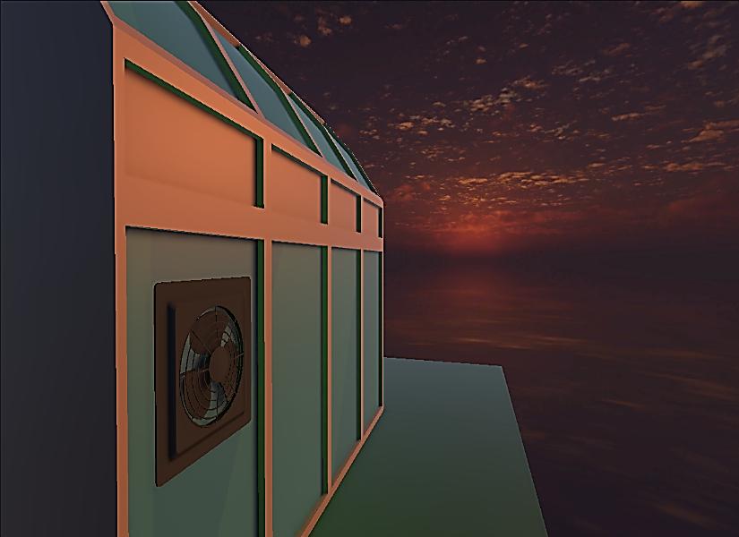
Fig. 35 Greenhouse Exterior View under Evening Conditions
Fig. 35 shows the exterior view of the greenhouse under evening conditions, with dynamic lighting effects that reflect the time-of-day simulation in the Unity model.
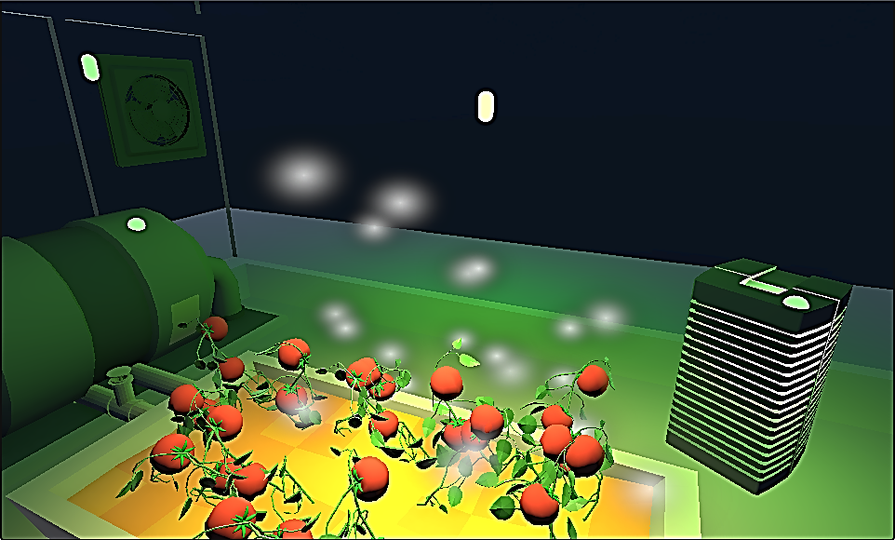
Fig. 36 Ripe Growth Stage Visualization inside 3D Greenhouse
Fig. 36 shows the ripe stage visualization inside the 3D greenhouse, with plant models visually representing mature, harvest-ready tomatoes consistent with the current growth stage prediction.

Comparative Performance Evaluation
Table VII compares the proposed growth stage classification model to existing approaches in terms of methodology, dataset, and accuracy. The EfficientNetB3-based model achieves competitive or superior accuracy with a smaller and more trainable parameter footprint than several comparable architectures.
Table VII. Comparative Analysis of Proposed Growth Stage Classification Model with Existing Approach
Parameter | Existing Work | Proposed Work
Model | StyleGAN3 + Vision Transformer (ViT) | EfficientNet (CNN-based Model)
Dataset | Original + Synthetic Images | Real + Augmented Dataset
Accuracy (%) | 98.39 | 98.61
Precision (%) | 98.47 | 98.67
Recall (%) | 98.39 | 98.61
F1 Score (%) | 98.39 | 98.62
Table VIII compares the proposed disease detection model against existing plant disease classification approaches. The two-stage transfer learning approach with EfficientNetB0 achieves strong accuracy while maintaining practical inference speed suitable for real-time greenhouse monitoring.
Table VIII. Performance Comparison of Plant Disease Classification Models
Parameter | Existing Work | Proposed Work
Model | Ensemble Learning (VGG16, VGG19, ResNet101V2, InceptionV3) | CNN-based Transfer Learning Model (EfficientNet)
Dataset | PlantVillage Dataset (38 disease classes) | Real + Augmented Dataset (PlantVillage / Custom)
Accuracy (%) | >90% | 98.23
Precision (%) | 93.45 | 98.27
Recall (%) | 92.67 | 98.23
F1 Score (%) | 92.66 | 98.23
Table IX compares the proposed hybrid weather forecasting model to existing single-model approaches. The ensemble consistently outperforms individual models on both 24-hour and 48-hour horizons across evaluation metrics.
Table IX. Performance Comparison of Weather Forecasting Models
Parameter | Existing Work | Proposed Work
Model Type | Numerical Weather Model (MM5) | Chronos + GRU-based Deep Learning Model  & Random Forest Classification Model
Forecast Horizon | 3 Days | 2 Days
Variables Predicted | Solar Radiation, Temperature, Wind Speed, Humidity | Temperature, Wind Speed, Humidity, Solar Radiation, Weather Condition
MAE (Solar Radiation) | 45.365 | 35.13
R² (Solar Radiation) | 0.867 | 0.886
MAE (Temperature) | 32.361 | 0.84
R² (Temperature) | 0.844 | 0.943
MAE (Wind Speed) | 170.598 | 4.68
R² (Wind Speed) | 0.867 | 0.885
MAE (Humidity) | 10.715 | 6.078
R² (Humidity) | 0.581 | 0.629
Table X evaluates existing greenhouse management systems against AgriTwin-GH across dimensions including predictive capability, disease intelligence, digital twin integration, and sensor independence. AgriTwin-GH covers more of these dimensions than any single compared system.
Table X. Comparative Analysis of Existing Systems and Proposed AgriTwin-GH Framework
Criteria | IoT-Based Systems | Digital Twin Systems | AgriTwin-GH (Proposed)
Monitoring Capability | Real-time sensor-based monitoring | Real-time + virtual monitoring | Multi-source intelligent monitoring
Disease Detection | Not supported | Limited | Integrated AI-based detection
Control Strategy | Semi-automated | Predictive (MPC-based) | Predictive + MPC & Simulation-based control
AI/ML Integration | Minimal | Moderate | Fully integrated AI framework
Decision Support | Limited | High | Intelligent decision-support system

CONCLUSION
AgriTwin-GH is a software-based digital twin framework developed to move greenhouse management for tomato cultivation from reactive to predictive and proactive. It brings together environmental data processing, image-based growth stage and disease classification using EfficientNet models, time-series forecasting for weather, disease, and plant growth, and a digital twin simulation layer coupled with Model Predictive Control. Rather than waiting until something goes wrong, the system continuously reads both environmental data and crop health signals to detect early stress, project how conditions will evolve, and test control strategies against a virtual greenhouse before applying them to a real one. One of the core contributions is the sensor-independent digital twin concept: by treating processed datasets as virtual sensors, the framework operates reliably without requiring physical sensing infrastructure — making it practical in cost-sensitive or resource-limited settings. Across all evaluation tasks, the system demonstrates strong predictive accuracy and stable simulation behavior. Overall, AgriTwin-GH provides a solid and scalable foundation for AI-driven greenhouse management that can be extended to support different crops, expanded sensor sources, and more demanding production environments.
Several directions are worth pursuing from here. Integrating physical IoT sensors would close the loop between the simulated and real greenhouse, enabling true continuous synchronization. Expanding disease and growth models to cover additional crop varieties beyond tomatoes would broaden applicability. Reinforcement learning offers a natural path to adaptive control strategies that improve over time from operational experience rather than requiring manual reconfiguration. On the environmental side, regional weather forecasts, satellite-based indicators, and local microclimate data would strengthen the system's ability to anticipate external disturbances before they affect the crop. Edge-based AI deployment would reduce latency in settings with limited connectivity. Finally, comprehensive field evaluations measuring improvements in resource efficiency, yield, and carbon footprint would validate the system's contributions to sustainable, precision agriculture at production scale.

References
- A. Benyezza, A. Bouhedda, and S. Rebouh, “Digital twins in greenhouse horticulture: A review,” Computers and Electronics in Agriculture, 2022.
- A. F. Subahi and K. E. Bouazza, “An intelligent IoT-based system design for controlling and monitoring greenhouse temperature,” IEEE Access, vol. 10, pp. 1–12, 2022.
- A. Kaur and R. Kaur, “AI-enabled energy management for sustainable smart greenhouses: An integrated review,” Journal of Cleaner Produelbasiction, vol. 382, pp. 1–15, 2024.
- A. Oad, S. S. Abbas, A. Zafar, et al., “Plant leaf disease detection using ensemble learning and explainable AI,” IEEE Access, vol. 12, pp. 156038–156052, 2024.
- A. Soussi, E. Zero, C. D. C. Herrera, et al., “Integrating digital twins and model predictive control for sustainable greenhouse management in smart agriculture,” IEEE Transactions on AgriFood Electronics, vol. 1, no. 1, pp. 1–17, 2025.
- B. V. Nikitha, N. K. S. Keerthan, P. Praneeth, and T. Amrita, “Leaf disease detection and classification,” Procedia Computer Science, vol. 218, pp. 291–300, 2023.
- D. A. Howard, Z. Ma, C. Veje, A. Clausen, J. M. Aaslyng, and B. N. Jørgensen, “Greenhouse industry 4.0 – digital twin technology for commercial greenhouses,” Energy Informatics, vol. 4, no. 1, pp. 1–20, 2021.
- D. K. Lee, B. K. Kang, Y. J. Kim, T. G. An, and Y. T. Chae, “A digital twin-based framework for precision tomato cultivation: Integrating XGBoost-based prediction with model predictive control,” SSRN Electronic Journal, 2024.
- D. S. Joseph, P. M. Pawar, and K. Chakradeo, “Real-time plant disease dataset development and detection of plant disease using deep learning,” IEEE Access, vol. 11, pp. 1–15, 2023.
- E. Elbasi, N. Mostafa, C. Zaki, Z. AlArnaout, A. E. Topcu, and L. Saker, “Optimizing agricultural data analysis techniques through AI-powered decision-making processes,” Applied Sciences, vol. 14, no. 8018, 2024.
- J. Silva, P. Costa, and L. Gomes, “A predictive greenhouse digital twin for controlled environment agriculture,” Proc. ICINCO, 2025.
- L. Caroprese, M. Pierantozzi, C. Lops, and S. Montelpare, “DL2F: A deep learning model for the local forecasting of renewable sources,” Computers & Industrial Engineering, vol. 187, 109785, 2024.
- M. Ghiasi, Z. Wang, M. Mehrandezh, and A. Mohammadi, “Optimal strategy for energy-efficient management of greenhouse climate control,” IEEE Open Access Journal of Power and Energy, vol. 12, pp. 1–14, 2025.
- M. R. Islam, et al., “Towards digital twin-enabled greenhouse management: Enhancing climate resilience and sustainability through machine learning-driven controlled environment agriculture,” Sustainable Energy Technologies and Assessments, 2026.
- M. Tan and Q. V. Le, “EfficientNet: Rethinking model scaling for convolutional neural networks,” Proc. ICML, 2019.
- M. Umar, S. Altaf, S. Ahmad, H. Mahmoud, A. S. N. Mohamed, and R. Ayub, “Precision agriculture through deep learning: Tomato plant multiple diseases recognition with CNN and improved YOLOv7,” IEEE Access, vol. 12, pp. 49167–49180, 2024.
- S. Hochreiter and J. Schmidhuber, “Long short-term memory,” Neural Computation, 1997.
- S. Kanakala and S. Ningappa, “Detection and classification of diseases in multi-crop leaves using LSTM and CNN models,” Journal of Innovative Image Processing, vol. 7, no. 1, pp. 161–181, 2025.
- S. P. Mohanty, D. P. Hughes, and M. Salathé, “Using deep learning for image-based plant disease detection,” Frontiers in Plant Science, 2016.
- S. R. Luna, M. P. García, and J. R. Torres, “Digital twin technology in greenhouse-based precision agriculture,” Computers and Electronics in Agriculture, vol. 209, pp. 107–119, 2023.
- T. Chen and C. Guestrin, “XGBoost: A scalable tree boosting system,” Proc. ACM SIGKDD, 2016.
- T. He, M. Li, and D. Jin, “Deep learning-based time series prediction for precision field crop protection,” Frontiers in Plant Science, vol. 16, 1575796, 2025.
- Y. Huo, Y. Liu, P. He, L. Hu, W. Gao, and L. Gu, “Identifying tomato growth stages in protected agriculture with StyleGAN3–synthetic images and Vision Transformer,” Agriculture, vol. 15, no. 120, 2025.
- Y. Zhang, X. Wang, et al., “Data-driven robust model predictive control for greenhouse temperature control and energy utilisation assessment,” Applied Energy, 2023.
- Z. Zhang, J. Li, and Y. Wang, “Digital twin-driven smart greenhouse management using deep learning and IoT integration,” Computers and Electronics in Agriculture, 2024.

